Control of Substances Hazardous to Health (COSHH) Risk Assessment Form
Name of substance: | CLEANLINE - PEACH BLOSSOM AIR FRESHENER
Other documents to be referenced using this substance: | Refer to manufactures Data Sheet
Assessment date: | 13/12/23
Review date:
Describe the activity or work process:  (Include how long and how often this is carried out and the quantity of substance used) | Refer to Manufacturers instructions
Identify the persons at risk: (Employees, Contractors, Public, Other – please specify) | Employee
Name of the manufacturer/supplier: | PRIME SOURCE P.O. BOX 15247, BIRMINGHAM, B22 3HN, UNITED KINGDOM Tel: 08085 749312
Concentration: | Propane 5-15%, Butane 5-15%, Propan-2-ol,isopropyl alcohol, isopropanol 1-5%
(A copy of a current safety data sheet for this substance must be attached to this assessment.)
Contents
Classification (Category of Danger) 1
Personal Protective Equipment (PPE) 2
First Aid and Emergency Measures 3
Storage, Handling, and Other Information 3
Signed 4

Classification (Category of Danger)
Danger | Symbol | Yes/No/Not Applicable (N/A)
Flammable | 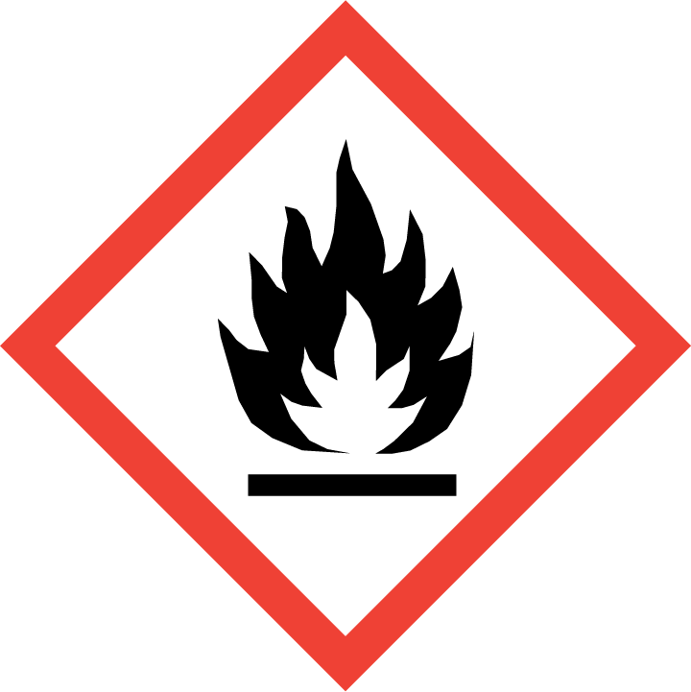 | Yes
Oxidising | 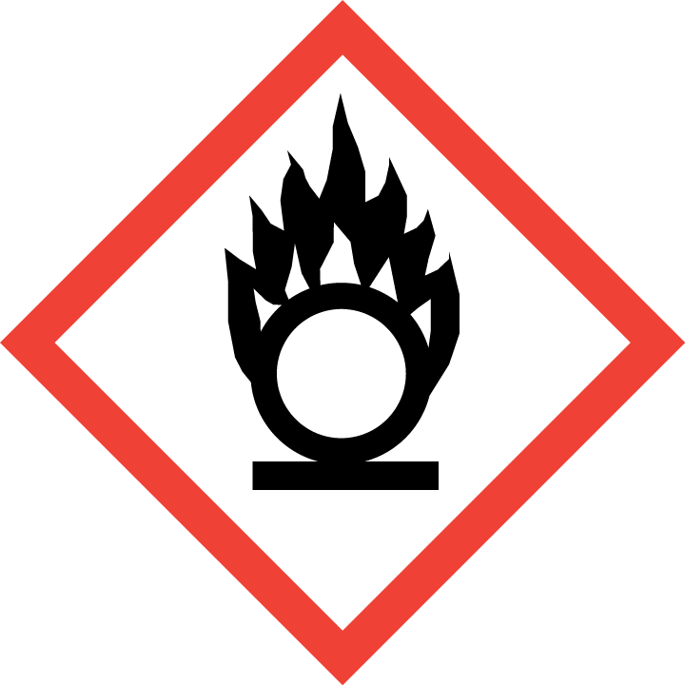
Explosive | 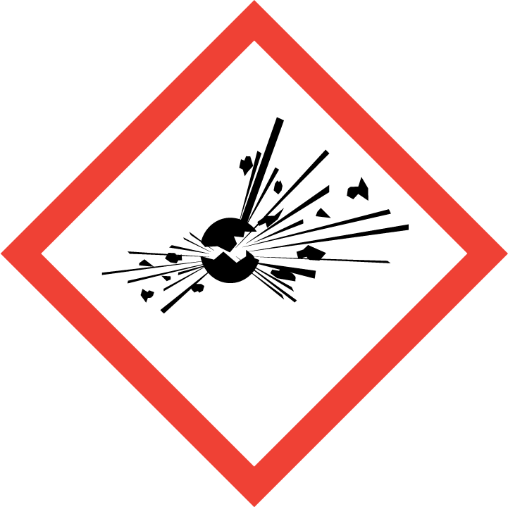
Irritant/Harmful | 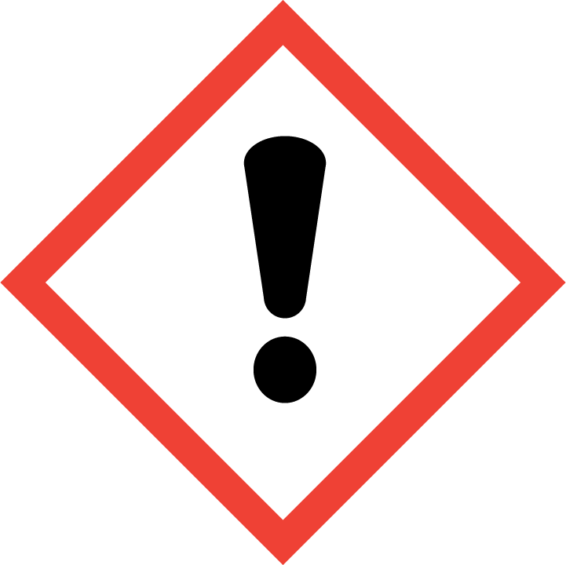
Environment | 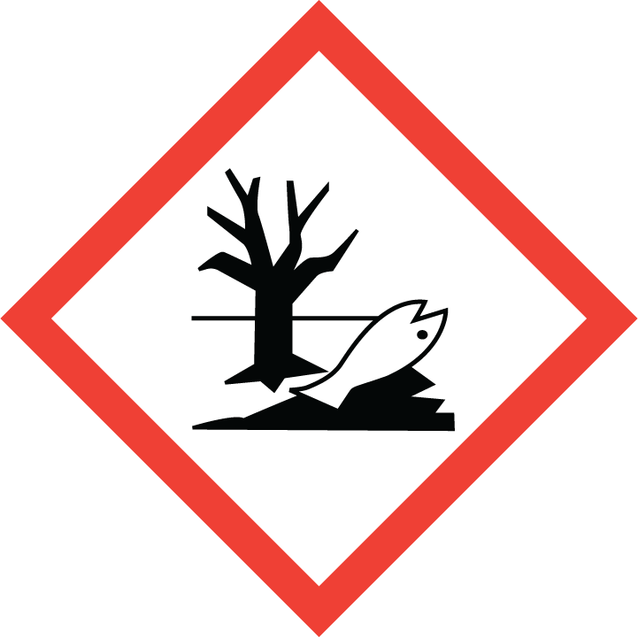
Carcinogenic | 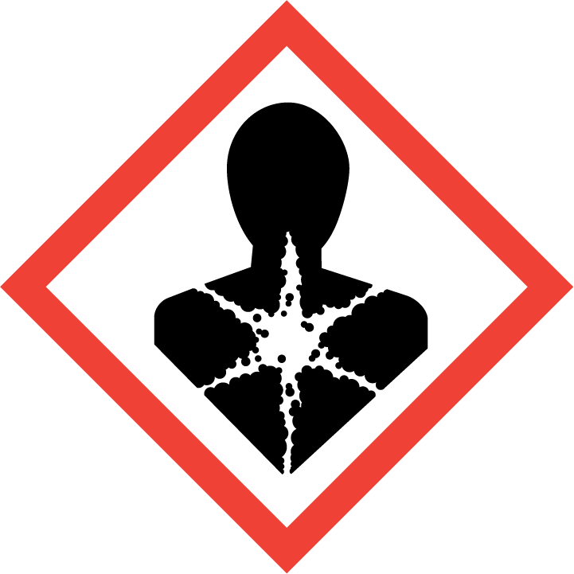
Corrosive | 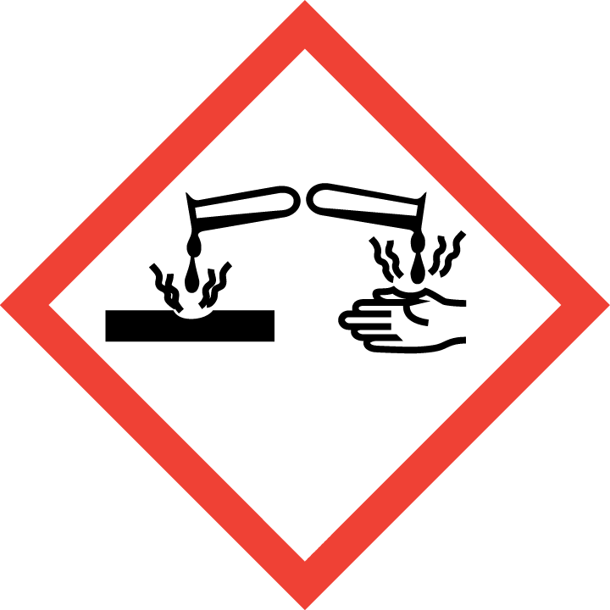
Toxic | 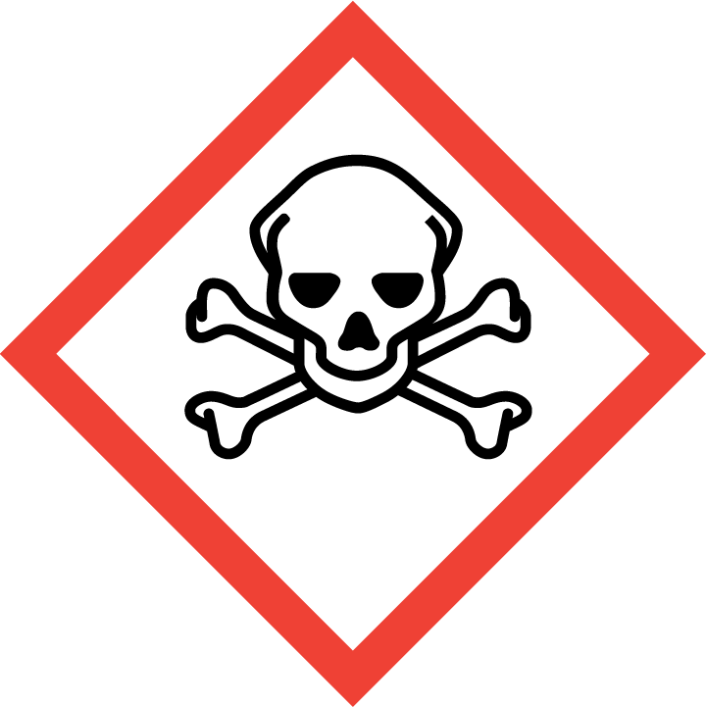
Pressurised | 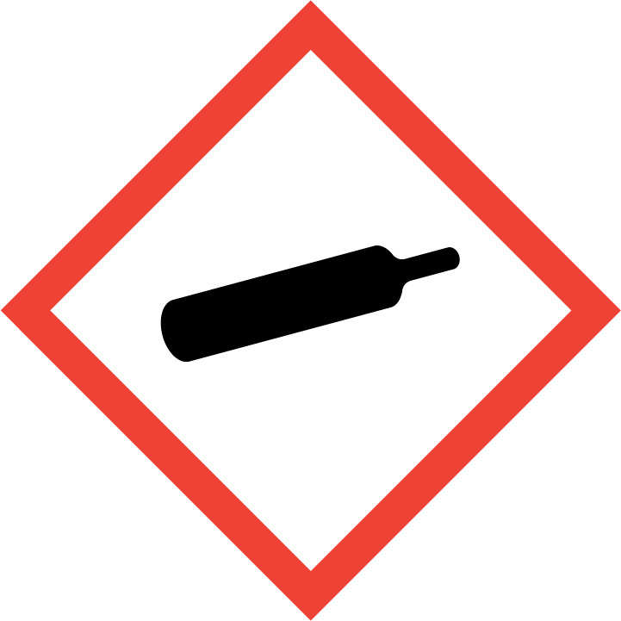
Other – please specify | 

Hazard/Precautionary Statements (must be included)
: H222 - Extremely flammable aerosol H229 - Pressurised container: May burst if heated P210 - Keep away from heat, hot surfaces, sparks, open flames and other ignition sources. No smoking P211 - Do not spray on an open flame or other ignition source P251 - Do not pierce or burn, even after use P410+P412 - Protect from sunlight. Do not expose to temperatures exceeding 50 °C/122 °F

Hazard Type | Yes/No/Not Applicable (N/A)
Gas
Vapour
Dust
Mist
Fume
Dust
Liquid | Yes
Solid
Other – please specify

Route of Exposure | Yes/No/Not Applicable (N/A)
Inhalation | Yes
Skin | Yes
Eyes | Yes
Ingestion | Yes
Injection | N/A
Other – please specify

Workplace Exposure Limits (WELs) - Please indicate if not applicable (N/A)
Short-term exposure (15 minutes)
Long-term exposure level (8 hour Time Weighted Average (TWA)) | N/A

Personal Protective Equipment (PPE)
Item | Symbol | If yes – specify type/standard
Air Fed Helmet
Face Visor
Goggles
Safety Glasses
Safety Boots/Shoes
Hand Protection |  | Yes
Overall
Apron
Lab Coat
Half Respirator
Full Respirator
Face Mask
Ventilation | 
Local Exhaust Ventilation | 
Used Outside | 
Other – please specify

First Aid and Emergency Measures
Contact Type | Description of First Aid Measures
Inhaled | Remove person to fresh air and keep comfortable for breathing
Skin Contact | Wash with plenty of soap and water
Eye Contact | IF IN EYES: Rinse cautiously with water for several minutes. Remove contact lenses, if present and easy to do. Continue rinsing. If eye irritation persists: Get medical advice/attention.
Swallowed | Do NOT induce vomiting. Rinse mouth. Drink plenty of water. Get medical advice/attention.

Emergency Measures | Yes/No/Not Applicable (N/A)
Is health surveillance required? | N/A
Is training required for this process? | N/A
Fire precautions: What actions will be taken in the event of a fire involving these substance(s)? | Extinguishing media Carbon Dioxide, Dry powder, Foam. Extremely flammable aerosol. Explosion risk in case of fire. Use water spray or fog for cooling exposed containers. Large fires call fire brigade, wear self-contained breathing apparatus and protective clothing. Breathed in: Remove person to fresh air and keep comfortable for breathing Disposal: How should the
How should an accidental release/spillage be dealt with? | Remove ignition sources, use ppe as required, avoid release into the environment, soak up spills with inhert solids, such as clay or diatomaceous earth ( or spill kit ) as soon as possible,collect spillage.Ventilate area

Storage, Handling, and Other Information
Handling | Pressurized container: Do not pierce or burn, even after use.  Do not spray on an open flame or other ignition source.  Do not eat, drink or smoke when using this product
Storage | Keep away from ignition sources. Protect from sunlight. Do not expose to temperatures exceeding 50 °C/122 °F  Oxidizing agent. Strong acids. Strong bases.  Direct sunlight. Heat sources. Sources of ignition  Keep only in original container.

Disposal Method – How should these substances be disposed of (or not disposed of?) | Yes/No/Not Applicable (N/A)
Hazardous waste
Skip | Do not pierce or burn, even after use
Return to depot
Return to supplier
Other (please state)

Signed
Assessment completed by: | Gillian Smith-Ward
Signature: | 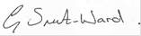
Date: | 13/6/23

Return to top of document

