Control of Substances Hazardous to Health (COSHH) Risk Assessment Form
Name of substance: | Cleanline Eco Washroom Cleaner
Other documents to be referenced using this substance: | Refer to Safety Data Sheet  Procurement Catalogue-Greenham
Assessment date: | January 2023
Review date: | January 2024
Describe the activity or work process:  (Include how long and how often this is carried out and the quantity of substance used) | A washroom cleaner used with either a cloth & spray or a mop & bucket to clean washroom surfaces and floors.
Identify the persons at risk: (Employees, Contractors, Public, Other – please specify) | Employees
Name of the manufacturer/supplier: | Prime Source  PO Box 15247  Birmingham  B23 3HN  UK  Tel: 08085 749312  E-mail: info@prime-source.co.uk
Concentration: | Alkyl (C12-16) dimethyl benzyl ammonium chloride (CAS-No.) 68424-85-1  (EC-No.) 270-325-2  < 1 Acute Tox. 4 (Oral), H302  Skin Corr. 1B, H314  Eye Dam. 1, H318  Aquatic Acute 1, H400 (M=10)  Aquatic Chronic 1, H410
(A copy of a current safety data sheet for this substance must be attached to this assessment.)
Contents
Classification (Category of Danger) 1
Personal Protective Equipment (PPE) 2
First Aid and Emergency Measures 3
Storage, Handling, and Other Information 3
Signed 4

Classification (Category of Danger)
Danger | Symbol | Yes/No/Not Applicable (N/A)
Flammable | 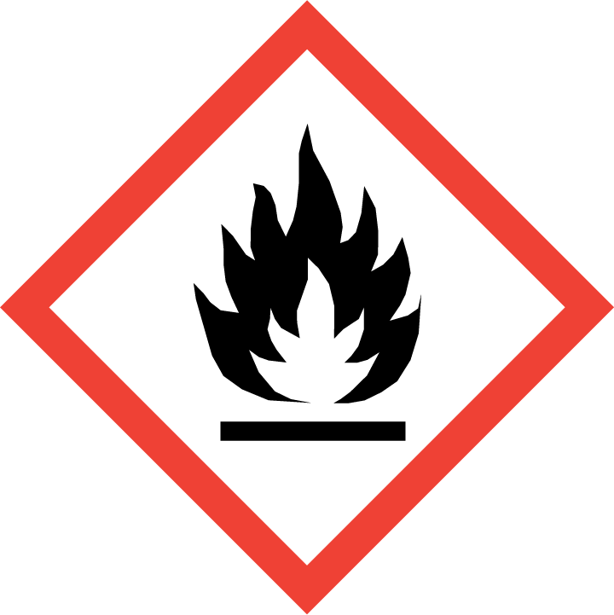
Oxidising | 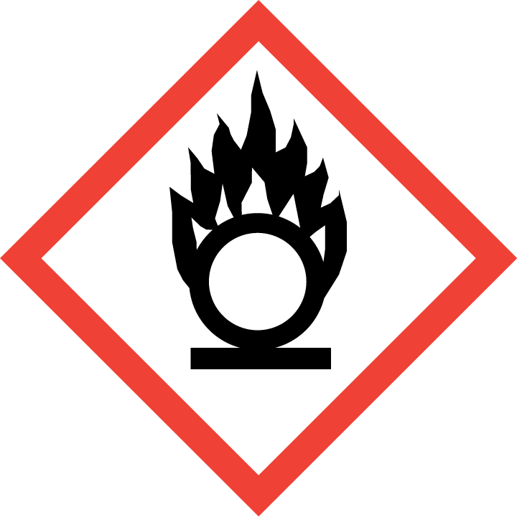
Explosive | 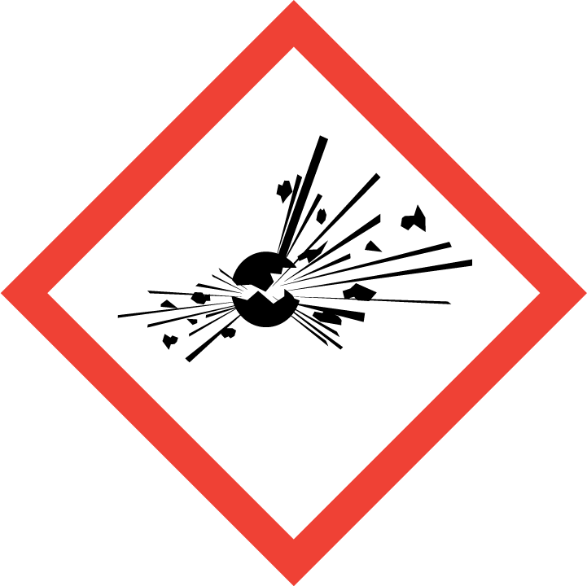
Irritant/Harmful | 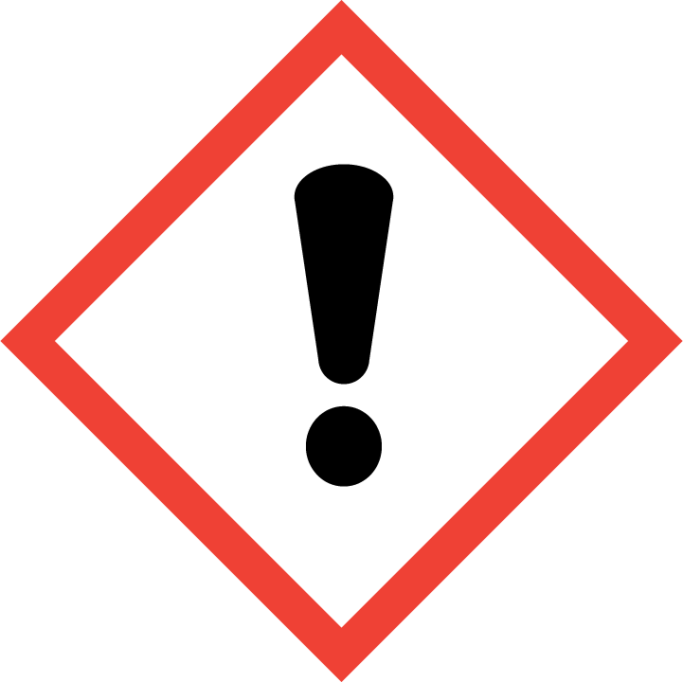
Environment | 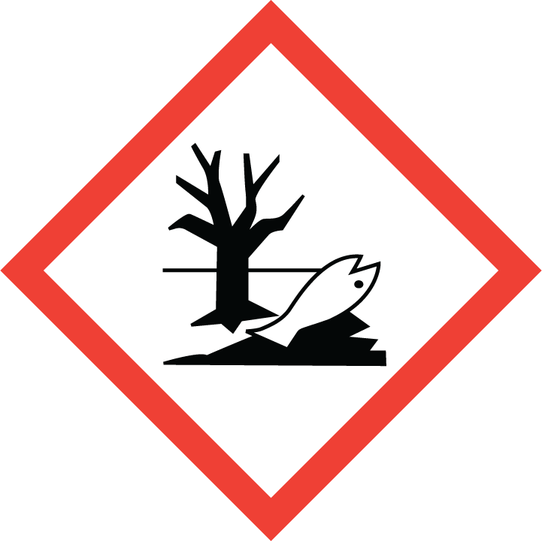 | Ys
Carcinogenic | 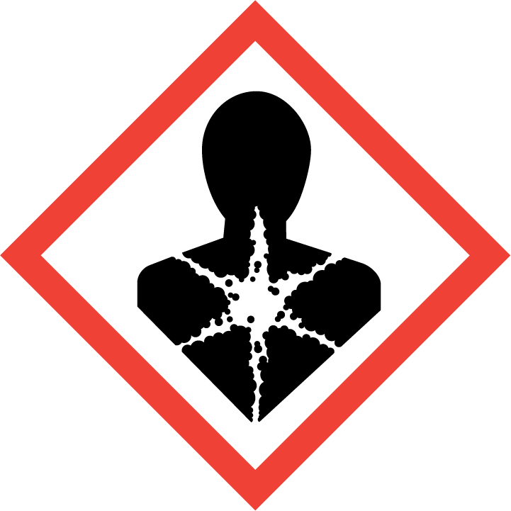
Corrosive | 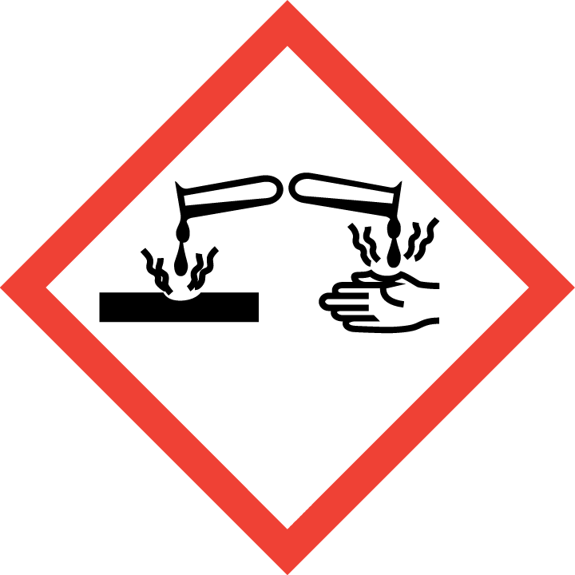
Toxic | 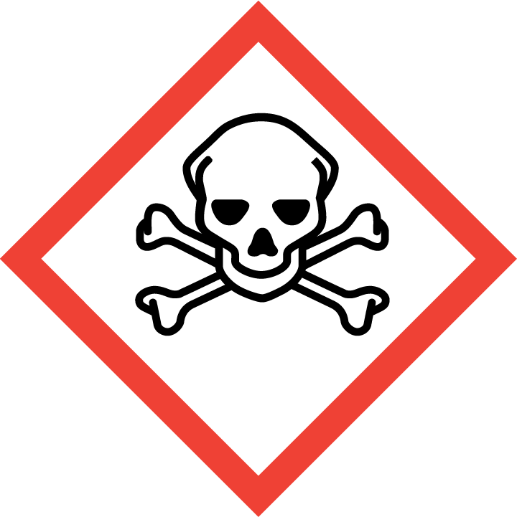
Pressurised | 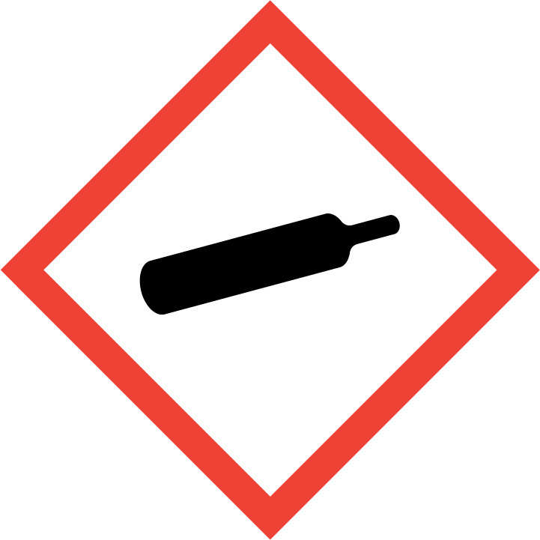
Other – please specify | 

Hazard/Precautionary Statements (must be included)
Harmful to aquatic life with long lasting effects.
P273 - Avoid release to the environment.

Hazard Type | Yes/No/Not Applicable (N/A)
Gas
Vapour
Dust
Mist
Fume
Dust
Liquid | Yes
Solid
Other – please specify

Route of Exposure | Yes/No/Not Applicable (N/A)
Inhalation | Yes
Skin | Yes
Eyes | Yes
Ingestion | Yes
Injection | N/A
Other – please specify | N/A

Workplace Exposure Limits (WELs) - Please indicate if not applicable (N/A)
Short-term exposure (15 minutes) | N/A
Long-term exposure level (8 hour Time Weighted Average (TWA)) | N/A

Personal Protective Equipment (PPE)
Item | Symbol | If yes – specify type/standard
Air Fed Helmet
Face Visor
Goggles
Safety Glasses |  | Yes EN166
Safety Boots/Shoes
Hand Protection |  | Yes EN374
Overall
Apron
Lab Coat
Half Respirator
Full Respirator
Face Mask
Ventilation | 
Local Exhaust Ventilation | 
Used Outside | 
Other – please specify

First Aid and Emergency Measures
Contact Type | Description of First Aid Measures
Inhaled | Remove person to fresh air and keep comfortable for breathing.
Skin Contact | Wash skin with plenty of water.
Eye Contact | Rinse eyes with water as a precaution.
Swallowed | Call a poison centre or a doctor if you feel unwell

Emergency Measures | Yes/No/Not Applicable (N/A)
Is health surveillance required? | No
Is training required for this process? | No
Fire precautions: What actions will be taken in the event of a fire involving these substance(s)? | Water spray. Dry powder. Foam. Carbon dioxide. Hazardous decomposition products in case of fire : Toxic fumes may be released.
How should an accidental release/spillage be dealt with? | Emergency procedures : Ventilate spillage area.  Protective equipment : Do not attempt to take action without suitable protective equipment.

Storage, Handling, and Other Information
Handling | Ensure good ventilation of the work station. Wear personal protective equipment.
Storage | Store in a well-ventilated place. Keep cool.  Incompatible products : Oxidizing agent. Strong acids. Strong bases.  Special rules on packaging : Keep only in original container. Store in a closed container

Disposal Method – How should these substances be disposed of (or not disposed of?) | Yes/No/Not Applicable (N/A)
Hazardous waste | No
Skip | No
Return to depot | No
Return to supplier | No
Other (please state) | Dispose of contents/container in accordance with licensed collector’s sorting instructions.

Signed
Assessment completed by: | Beverley Attle
Signature: | B.Attle
Date: | 31st January 2023

Return to top of document

