Control of Substances Hazardous to Health (COSHH) Risk Assessment Form
Name of substance: | Cif Professional Cream
Other documents to be referenced using this substance: | Safety Data Sheet  Manufacturer’s label
Assessment date: | 14/03/2023
Review date: | 14/03/2026
Describe the activity or work process:  (Include how long and how often this is carried out and the quantity of substance used) | Hard surface cleaner
Identify the persons at risk: (Employees, Contractors, Public, Other – please specify) | Employees
Name of the manufacturer/supplier: | Diversey  Weston Favell Centre  Northampton  NN38PD  United Kingdom  Tel. 01604405311  Email. Customerservice.uk@diversey.com  Emergency medical or environmental  tel. 0800 052 0185
Concentration: | Calcium Carbonate 20-30%  Sodium Alkybenzenesulphonate 3-10%  Sodium Carbonate 1-3%  Alcohols, C12-15, Ethoxylated 1-3%
(A copy of a current safety data sheet for this substance must be attached to this assessment.)
Contents
Classification (Category of Danger) 1
Personal Protective Equipment (PPE) 2
First Aid and Emergency Measures 3
Storage, Handling, and Other Information 3
Signed 4

Classification (Category of Danger)
Danger | Symbol | Yes/No/Not Applicable (N/A)
Flammable | 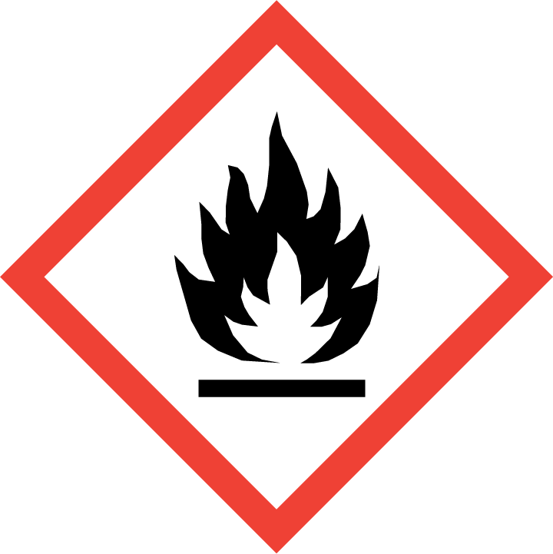
Oxidising | 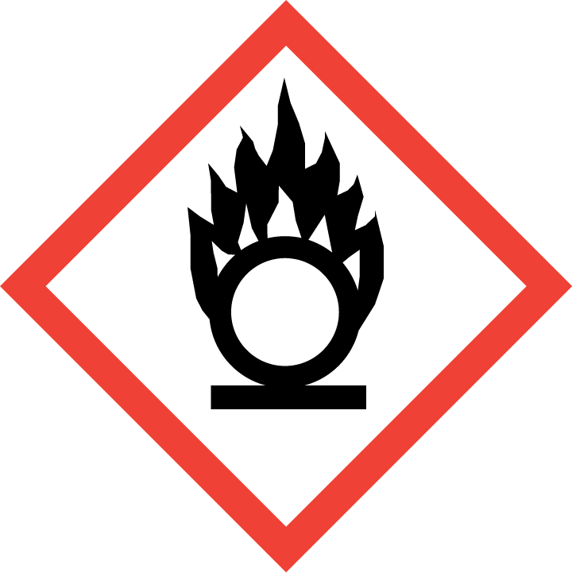
Explosive | 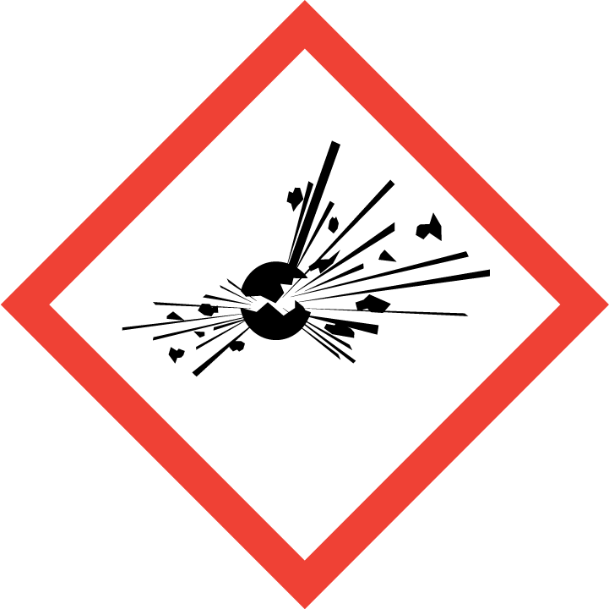
Irritant/Harmful | 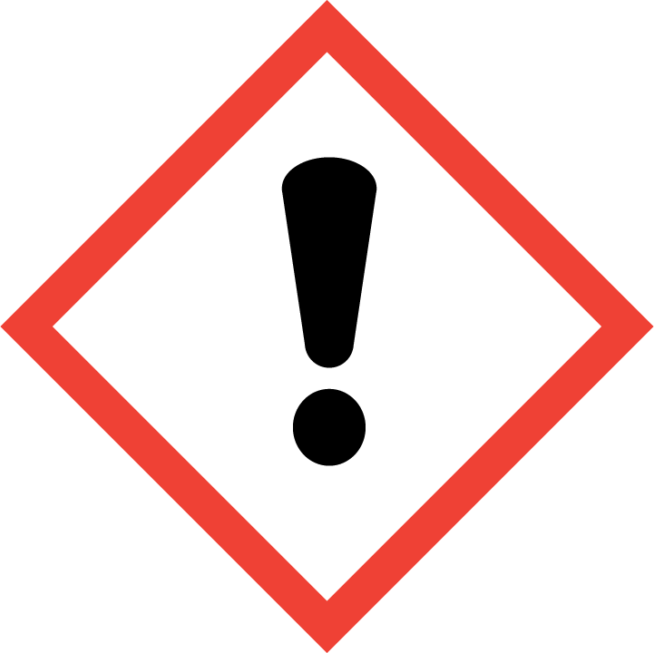 | Yes
Environment | 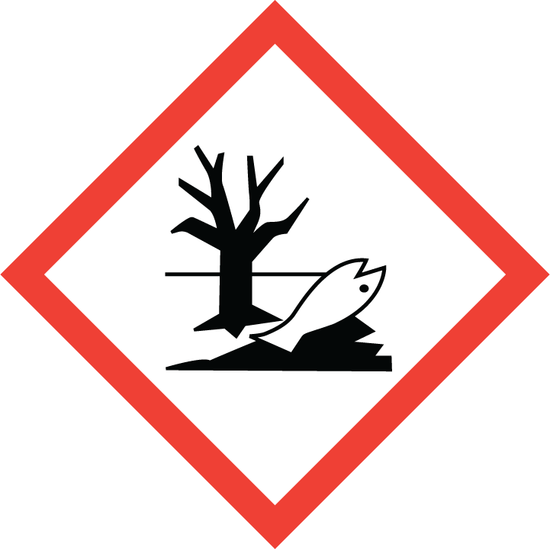
Carcinogenic | 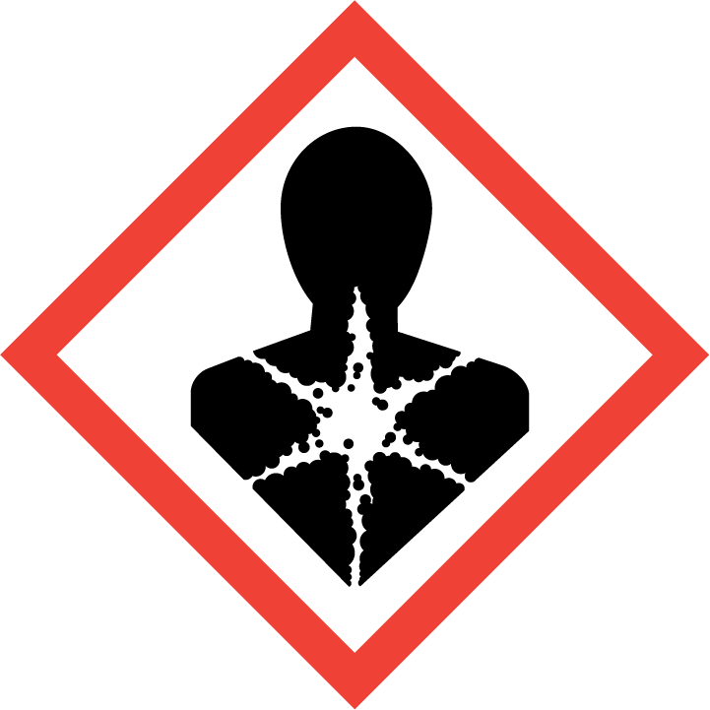
Corrosive | 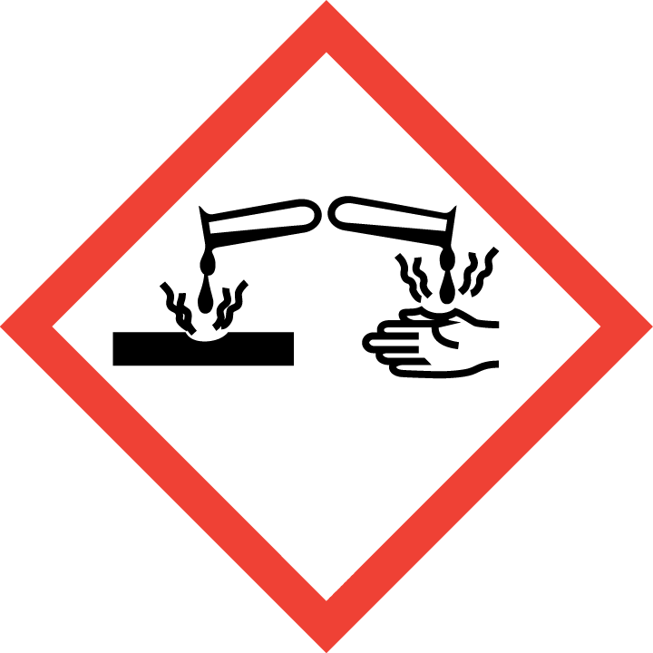
Toxic | 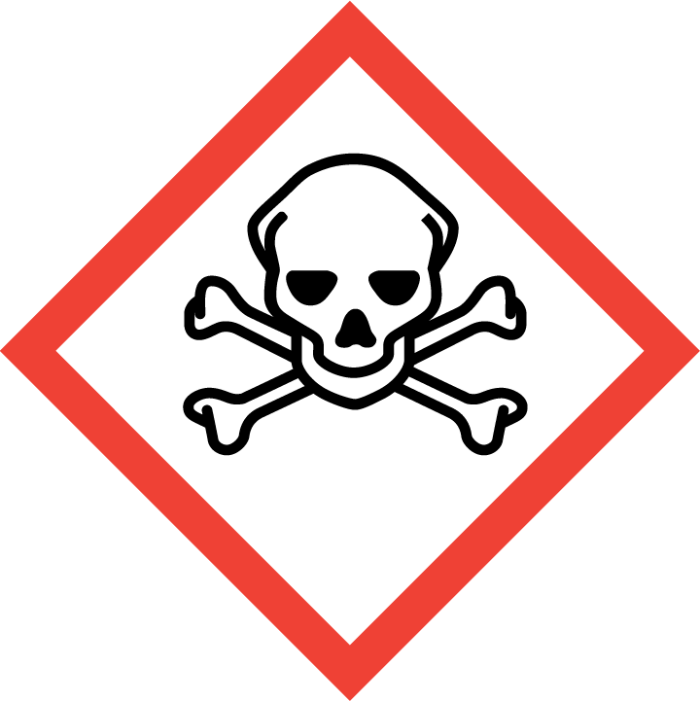
Pressurised | 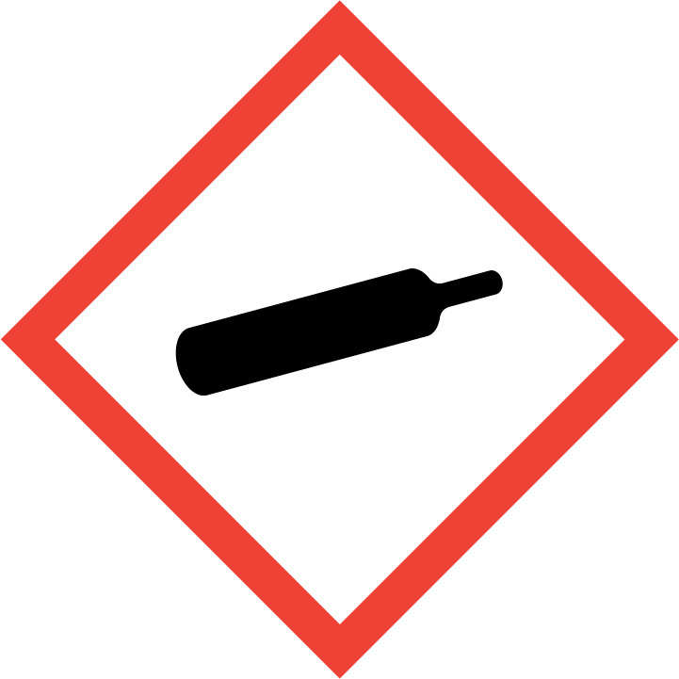
Other – please specify | 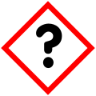

Hazard/Precautionary Statements (must be included)
Causes serious eye irritation.
If medical advice is needed, have product container or label at hand.
Keep out of reach of children.

Hazard Type | Yes/No/Not Applicable (N/A)
Gas
Vapour
Dust
Mist
Fume
Dust
Liquid | Yes
Solid
Other – please specify

Route of Exposure | Yes/No/Not Applicable (N/A)
Inhalation | Yes
Skin | Yes
Eyes | Yes
Ingestion | Yes
Injection
Other – please specify

Workplace Exposure Limits (WELs) - Please indicate if not applicable (N/A)
Short-term exposure (15 minutes) | n/a
Long-term exposure level (8 hour Time Weighted Average (TWA)) | n/a

Personal Protective Equipment (PPE)
Item | Symbol | If yes – specify type/standard
Air Fed Helmet
Face Visor
Goggles |  | Yes EN166
Safety Glasses |  | Yes EN166
Safety Boots/Shoes
Hand Protection |  | Yes EN374
Overall
Apron
Lab Coat
Half Respirator
Full Respirator
Face Mask
Ventilation | 
Local Exhaust Ventilation | 
Used Outside | 
Other – please specify

First Aid and Emergency Measures
Contact Type | Description of First Aid Measures
Inhaled | Get medical attention if you feel unwell.
Skin Contact | Wash skin with plenty of lukewarm, gentle flowing water. If skin irritation occurs, get medical advice or attention.
Eye Contact | Hold eyelids apart and flush eyes with plenty of lukewarm water for at least 15 minutes. Remove contact lenses, if present and easy to do. Continue rinsing. If irritation occurs and persists, get medical attention.
Swallowed | Rinse mouth. Immediately drink one glass of water. Never give anything by mouth to an unconscious person. Get medical advice or attention if you feel unwell.

Emergency Measures | Yes/No/Not Applicable (N/A)
Is health surveillance required? | n/a
Is training required for this process? | n/a
Fire precautions: What actions will be taken in the event of a fire involving these substance(s)? | Extinguishing media carbon dioxide. Dry powder. Water jet spray. Fight larger fires with water spray jet or alcohol resistant foam.  No special hazards known.  Advice for fire-fighters. As in any fire, wear self-contained breathing apparatus and suitable protective clothing including gloves and eye/face protection.
How should an accidental release/spillage be dealt with? | Personal precautions, protective equipment and emergency procedures. PPE equipment use gloves and eye protection.  Dilute with plenty of water. Do not allow to enter the drainage system, surface or ground water.  Dyke to collect large liquid spills. Absorb with liquid-binding material (sand, dolomite, universal binders, sawdust). Do not place spilled materials back into the original container. Collect in closed and suitable containers for disposal.

Storage, Handling, and Other Information
Handling | No special precautions required. Follow general hygiene considerations recognised as common good workplace practises. Keep away from food, drink and animal feeding stuffs. Keep out of reach of children. Do not mix with other products unless advised by Diversey. Wash face, hands and any exposed skin thoroughly after handling. Avoid contact with eyes. Use only with adequate ventilation.
Storage | Store in accordance with local and national regulations. Store in a closed container. Keep only in original packaging. Keep out of reach of children.

Disposal Method – How should these substances be disposed of (or not disposed of?) | Yes/No/Not Applicable (N/A)
Hazardous waste
Skip
Return to depot
Return to supplier
Other (please state) | The concentrated contents or contaminated packaging should be disposed of by a certified handler or according to the site permit. Release of waste to sewers is discouraged. The cleaned packaging material is suitable for energy recovery or recycling in line with local legislation.  Dispose of observing national or local regulations. Water, if necessary with cleaning agent.

Signed
Assessment completed by: | Kathryn Elliott
Signature: | 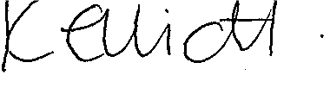
Date: | 14/03/2023

Return to top of document

