Control of Substances Hazardous to Health (COSHH) Risk Assessment Form
Name of substance: | Oxybac
Other documents to be referenced using this substance: | Safety Data Sheet  Manufacturer’s Label
Assessment date: | 16/03/2023
Review date: | 16/03/2026
Describe the activity or work process:  (Include how long and how often this is carried out and the quantity of substance used) | Human hygiene biocidal product
Identify the persons at risk: (Employees, Contractors, Public, Other – please specify) | Employees
Name of the manufacturer/supplier: | SC Johnson Professional Ltd  Denby Hall Way  Denby  Derbyshire  DE5 8JZ  Tel. 01773 855100  Email info.prouk@scj.com  National poisons information service tel. 03448920111 health professionals only
Concentration: | 2-Phenoxethanol 1-10%  Glycerin 1-10%  2-Methylpentane-2,4-Diol 1-10%  Hydrogen Peroxide Solution 1-10%  D-Glucopyranose, Oligomeric, C10-16 Alkyl Glycosides 1-10%  Amines, C12-14 (even numbered) Alkyldimethyl, N-Oxides 1-10%  Phosphoric Acid <1%
(A copy of a current safety data sheet for this substance must be attached to this assessment.)
Contents
Classification (Category of Danger) 1
Personal Protective Equipment (PPE) 2
First Aid and Emergency Measures 3
Storage, Handling, and Other Information 3
Signed 4

Classification (Category of Danger)
Danger | Symbol | Yes/No/Not Applicable (N/A)
Flammable | 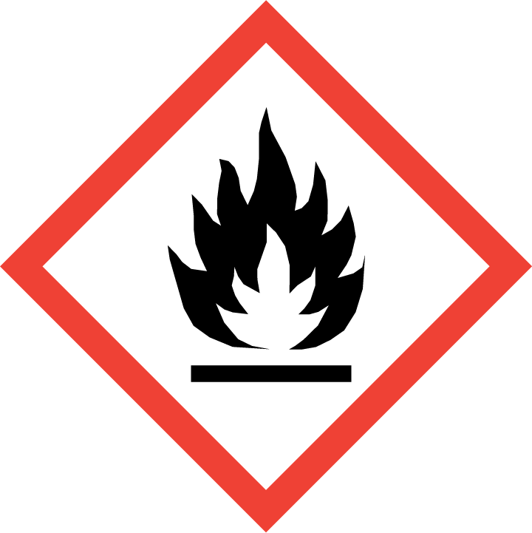
Oxidising | 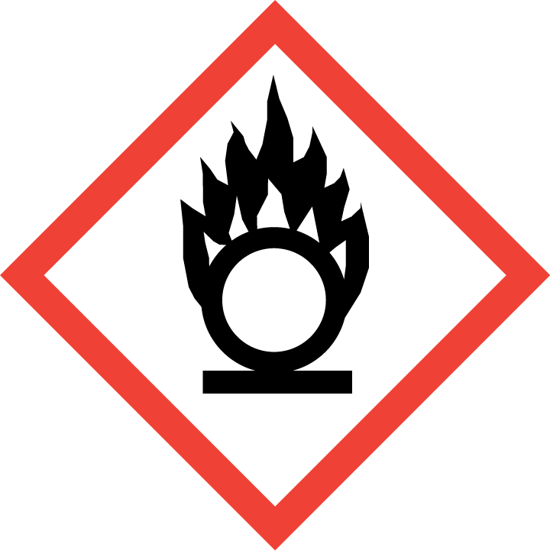
Explosive | 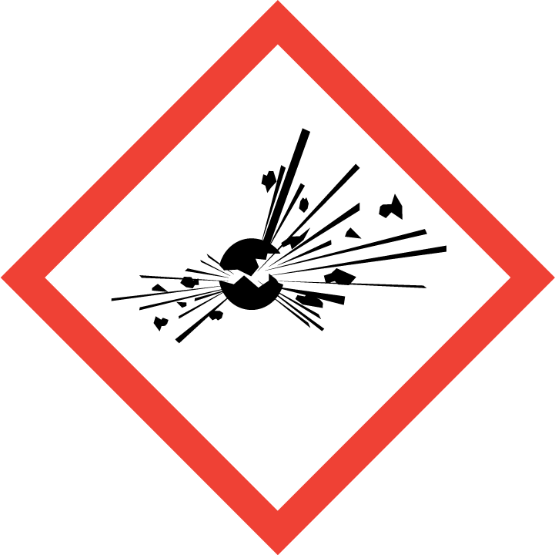
Irritant/Harmful | 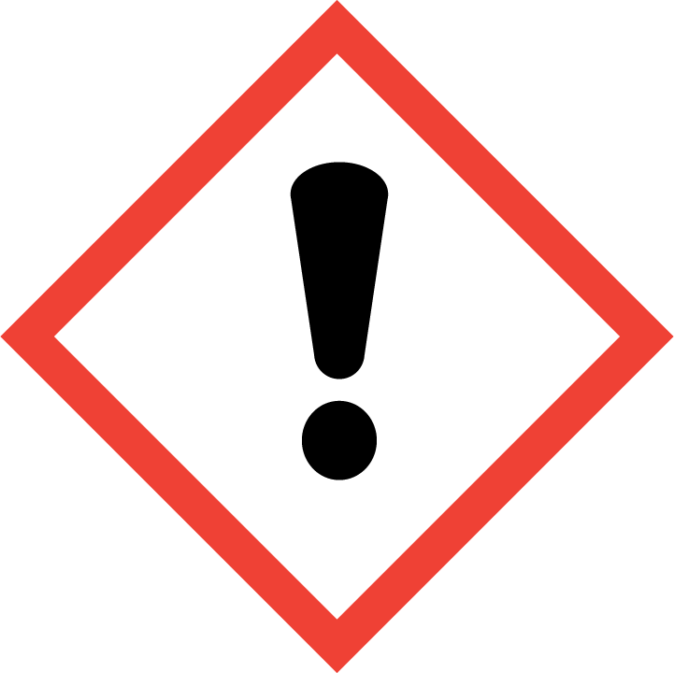 | Yes
Environment | 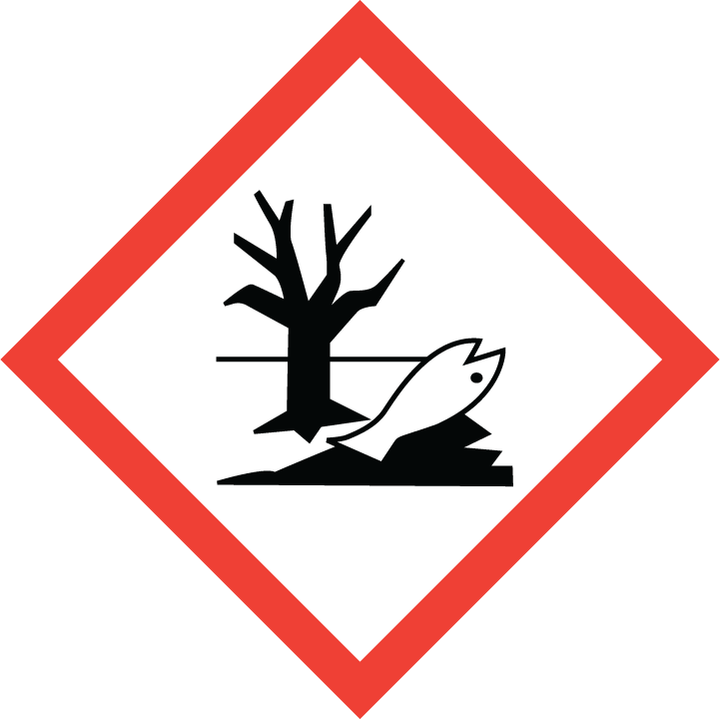
Carcinogenic | 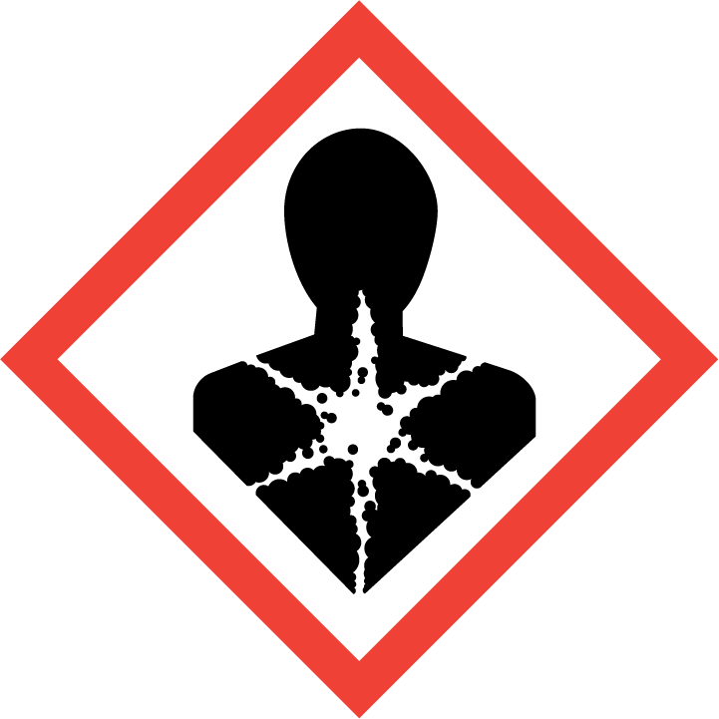
Corrosive | 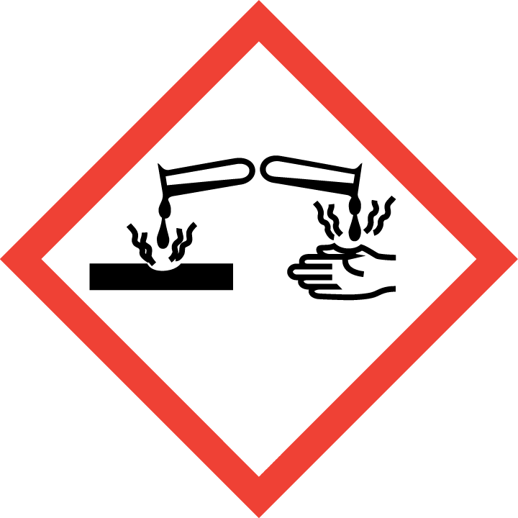
Toxic | 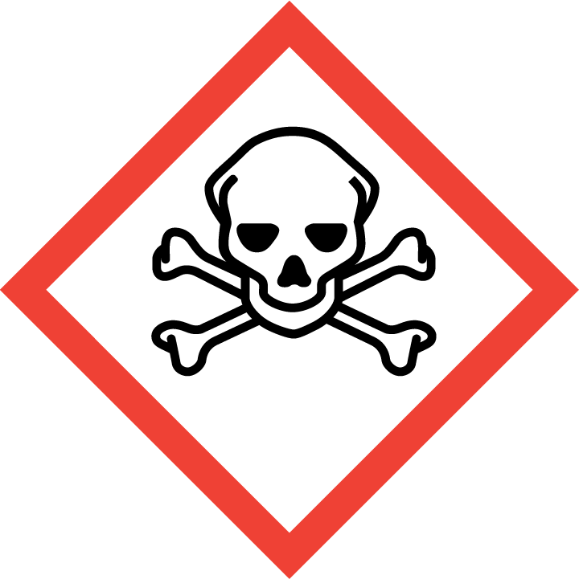
Pressurised | 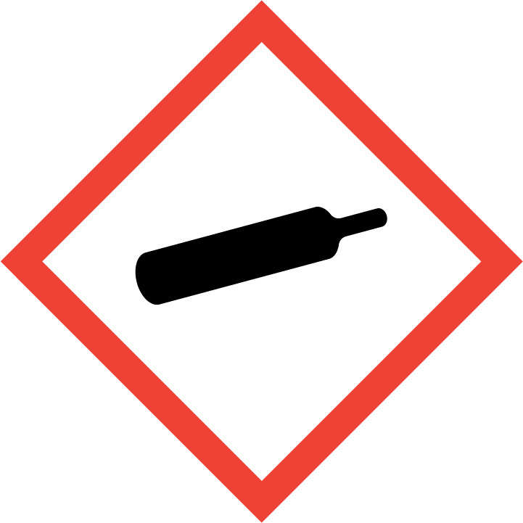
Other – please specify | 

Hazard/Precautionary Statements (must be included)
Causes serious eye irritation.
If in eyes rinse cautiously with water for several minutes. Remove contact lenses, if present and easy to do. Continue rinsing.
If eye irritation persists get medical advice/ attention.
Store in accordance with local regulations. Dispose of contents/container in accordance with local regulations.
Use biocides safely. Always read the label and product information before use.
Eye protection not required normally but wear eye protection if you are conducting an operation where there is a risk of this product getting in the eyes.

Hazard Type | Yes/No/Not Applicable (N/A)
Gas
Vapour
Dust
Mist
Fume
Dust
Liquid | Yes
Solid
Other – please specify

Route of Exposure | Yes/No/Not Applicable (N/A)
Inhalation | n/a
Skin | Yes
Eyes | Yes
Ingestion | Yes
Injection
Other – please specify

Workplace Exposure Limits (WELs) - Please indicate if not applicable (N/A)
Short-term exposure (15 minutes) | 15 minutes
Long-term exposure level (8 hour Time Weighted Average (TWA)) | 8 hours

Personal Protective Equipment (PPE)
Item | Symbol | If yes – specify type/standard
Air Fed Helmet
Face Visor
Goggles |  | Yea EN166
Safety Glasses |  | Yes EN166
Safety Boots/Shoes
Hand Protection
Overall
Apron
Lab Coat
Half Respirator
Full Respirator
Face Mask
Ventilation | 
Local Exhaust Ventilation | 
Used Outside | 
Other – please specify

First Aid and Emergency Measures
Contact Type | Description of First Aid Measures
Inhaled | Unlikely route of exposure as this product doesn’t contain volatile substances.
Skin Contact | Rinse with water.
Eye Contact | Remove any contact lenses and open eyelids wide apart.  Continue to rinse for at least 15 minutes.  Get medical attention promptly if symptoms occur after washing.
Swallowed | Rinse mouth thoroughly with water. Get medical attention if any discomfort continues.

Emergency Measures | Yes/No/Not Applicable (N/A)
Is health surveillance required? | n/a
Is training required for this process? | n/a
Fire precautions: What actions will be taken in the event of a fire involving these substance(s)? | This product is not flammable.  Use fire-extinguishing media suitable for the surrounding fire.  No known hazardous decomposition products.  No specific firefighting precautions known.
How should an accidental release/spillage be dealt with? | Avoid contact with eyes.  Avoid or minimise the creation of any environmental contamination.  Avoid contamination of ponds or watercourses with washing down water.  Avoid contamination of ponds or watercourses with washing down water absorb spillage with non-combustible, absorbent material.  Do not discharge into watercourses or onto the ground.

Storage, Handling, and Other Information
Handling | Avoid contact with eyes.
Storage | Store in tightly closed, original container in a cool dry place.  Protect from light.  Keep away from food and children.

Disposal Method – How should these substances be disposed of (or not disposed of?) | Yes/No/Not Applicable (N/A)
Hazardous waste
Skip
Return to depot
Return to supplier
Other (please state) | When handling waste, the safety precautions applying to the handling of the product should be considered.  Dispose of waste product or used containers in accordance with the requirements of the local waste disposal authority. Reuse or recycle products whenever possible.

Signed
Assessment completed by: | Kathryn Elliott
Signature: | 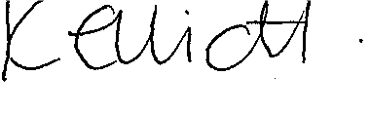
Date: | 16/03/2023

Return to top of document

