Control of Substances Hazardous to Health (COSHH) Risk Assessment Form
Name of substance: | T003 Kitchen Cleaner / Sanitiser
Other documents to be referenced using this substance: | Safety Data Sheet  Manufacturers Label
Assessment date: | 03/03/2023
Review date: | 03/03/2026
Describe the activity or work process:  (Include how long and how often this is carried out and the quantity of substance used) | Once benches or equipment have been cleaned this sanitiser is sprayed onto surfaces and left for a few minutes before removing with a soft cloth or blue roll.
Identify the persons at risk: (Employees, Contractors, Public, Other – please specify) | Employees
Name of the manufacturer/supplier: | Selden Research Limited  Staden Lane  Buxton  Derbyshire  SK17 9RZ  Tel. 01298 26226  Email safety@selden.co.uk
Concentration: | Quaternary ammonia compounds, benzyl-C12-16-alkyldimethyl, chlorides 0.1-1%  Cationic surfactants, non-ionic surfactants <5%
(A copy of a current safety data sheet for this substance must be attached to this assessment.)
Contents
Classification (Category of Danger) 1
Personal Protective Equipment (PPE) 2
First Aid and Emergency Measures 3
Storage, Handling, and Other Information 3
Signed 4

Classification (Category of Danger)
Danger | Symbol | Yes/No/Not Applicable (N/A)
Flammable | 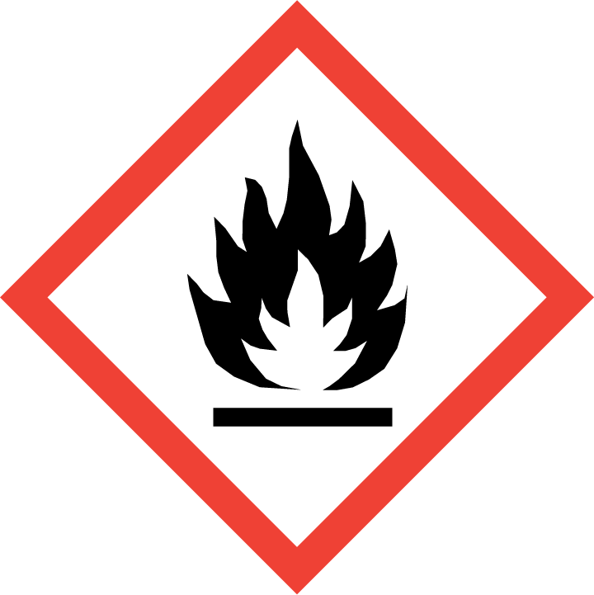
Oxidising | 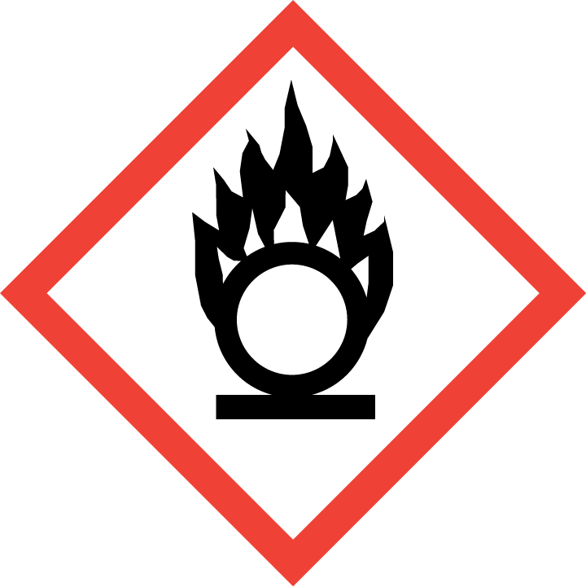
Explosive | 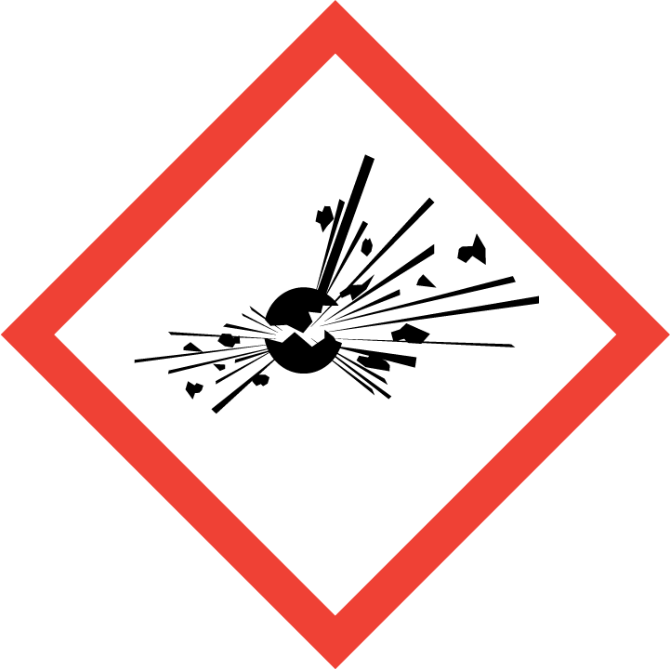
Irritant/Harmful | 
Environment | 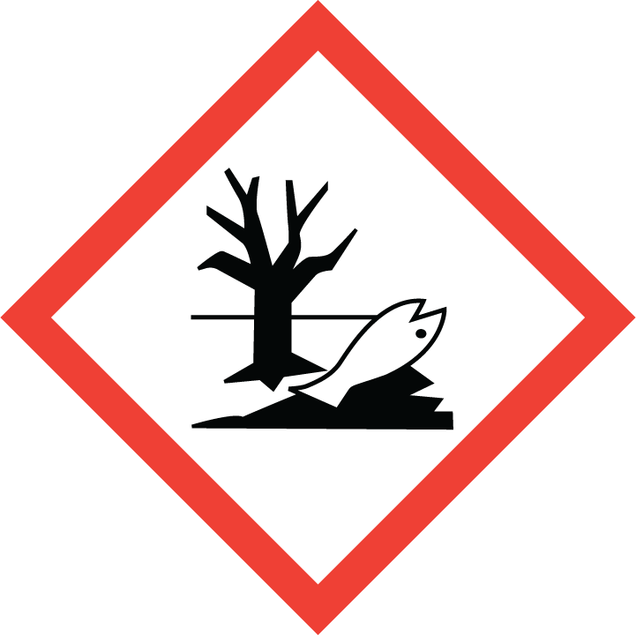
Carcinogenic | 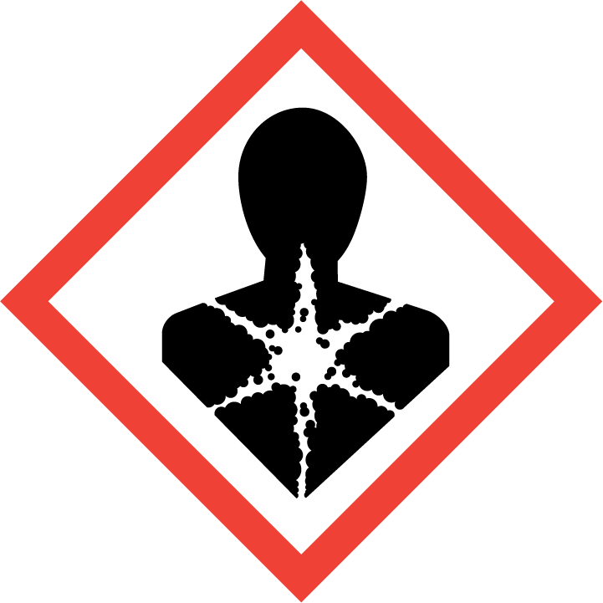
Corrosive | 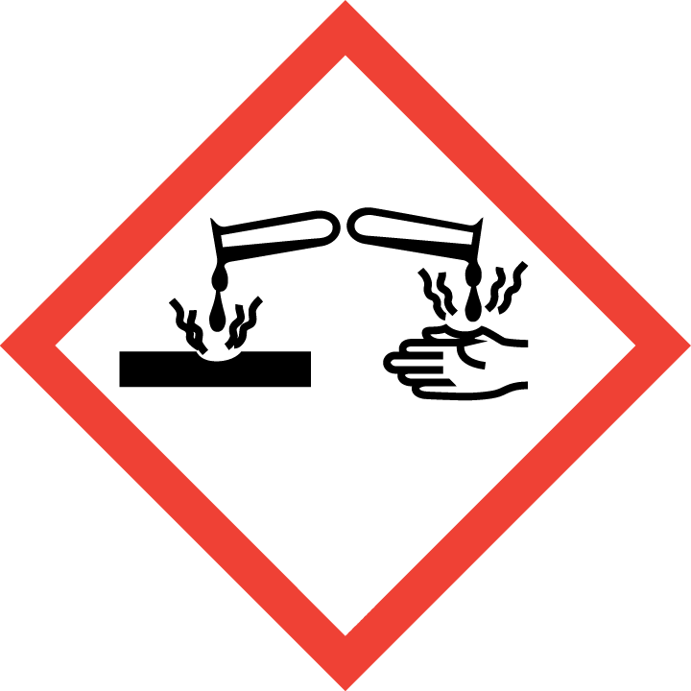
Toxic | 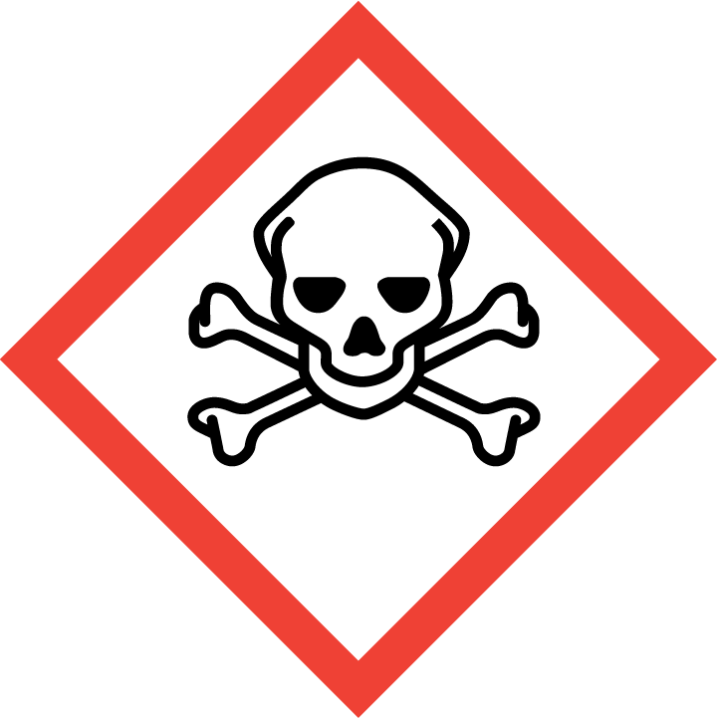
Pressurised | 
Other – please specify |  | None listed

Hazard/Precautionary Statements (must be included)
Repeated or prolonged skin contact may cause skin irritation.
May cause slight irritation after eye contact.

Hazard Type | Yes/No/Not Applicable (N/A)
Gas
Vapour
Dust
Mist
Fume
Dust
Liquid | Yes
Solid
Other – please specify

Route of Exposure | Yes/No/Not Applicable (N/A)
Inhalation | Yes
Skin | Yes
Eyes | Yes
Ingestion | Yes
Injection
Other – please specify

Workplace Exposure Limits (WELs) - Please indicate if not applicable (N/A)
Short-term exposure (15 minutes) | n/a
Long-term exposure level (8 hour Time Weighted Average (TWA)) | n/a

Personal Protective Equipment (PPE)
Item | Symbol | If yes – specify type/standard
Air Fed Helmet
Face Visor
Goggles |  | Yes EN166
Safety Glasses |  | Yes EN166
Safety Boots/Shoes
Hand Protection |  | Yes EN374
Overall
Apron
Lab Coat
Half Respirator
Full Respirator
Face Mask
Ventilation | 
Local Exhaust Ventilation | 
Used Outside | 
Other – please specify

First Aid and Emergency Measures
Contact Type | Description of First Aid Measures
Inhaled | Remove person to fresh air and keep comfortable for breathing.
Skin Contact | Wash shin with plenty of water.
Eye Contact | If in eyes rinse cautiously for several minutes. Remove contact lenses, if present and east to do. Continue rinsing. If eye irritation persists get medical advice / attention.
Swallowed | Give nothing or a little water to drink. Get medical advice / attention if you feel unwell

Emergency Measures | Yes/No/Not Applicable (N/A)
Is health surveillance required? | n/a
Is training required for this process? | n/a
Fire precautions: What actions will be taken in the event of a fire involving these substance(s)? | Carbon dioxide. Dry powder. Foam.
How should an accidental release/spillage be dealt with? | Evacuate unnecessary personnel.  Use personal protective equipment as required  Collect spillage.  Soak up spills with inert solids, such as clay or diatomaceous earth as soon as possible.

Storage, Handling, and Other Information
Handling | Avoid contact with eyes.  Do not smoke, eat or drink while handling this product.  Gloves are recommended for prolonged use.
Storage | Does not require any specific or particular technical measures.  Keep container closed when not in use.  Incompatible products are Oxidising agent. Strong acids. Strong bases.  Keep in original packaging.  Keep away from children and food.

Disposal Method – How should these substances be disposed of (or not disposed of?) | Yes/No/Not Applicable (N/A)
Hazardous waste
Skip
Return to depot
Return to supplier
Other (please state) | Dispose of as per local regulations.

Signed
Assessment completed by: | Kathryn Elliott
Signature: | 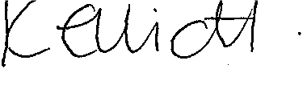
Date: | 03/03/2023

Return to top of document

