Control of Substances Hazardous to Health (COSHH) Risk Assessment Form
Name of substance:
Other documents to be referenced using this substance:
Assessment date:
Review date:
Describe the activity or work process:
(Include how long and how often this is carried out and the quantity of substance used)
Identify the persons at risk: (Employees, Contractors, Public, Other – please specify)
Name of the manufacturer/supplier:
Concentration:
(A copy of a current safety data sheet for this substance must be attached to this assessment.)
Contents
Classification (Category of Danger) 1
Personal Protective Equipment (PPE) 2
First Aid and Emergency Measures 3
Storage, Handling, and Other Information 3
Signed 4

Classification (Category of Danger)
Danger | Symbol | Yes/No/Not Applicable (N/A)
Flammable | 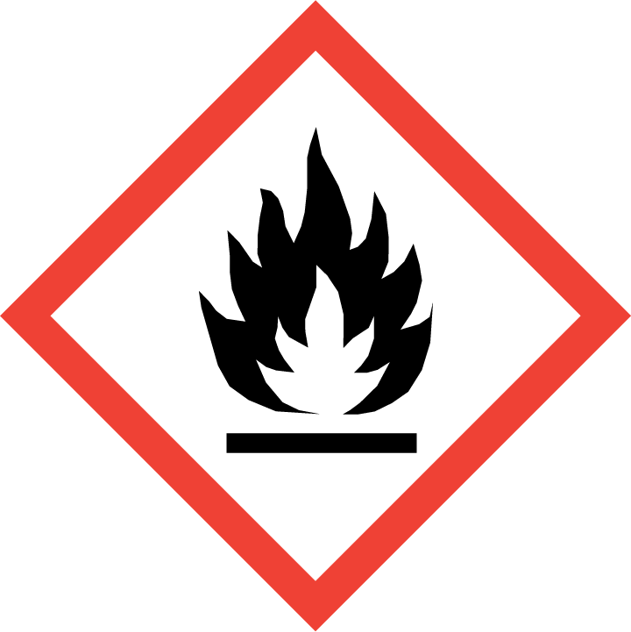
Oxidising | 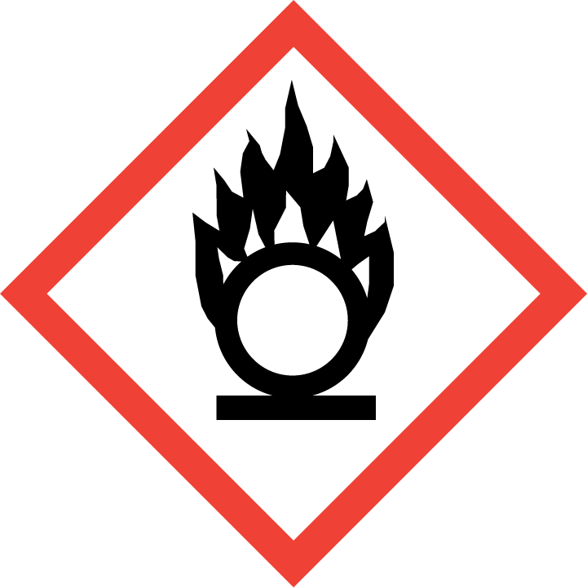
Explosive | 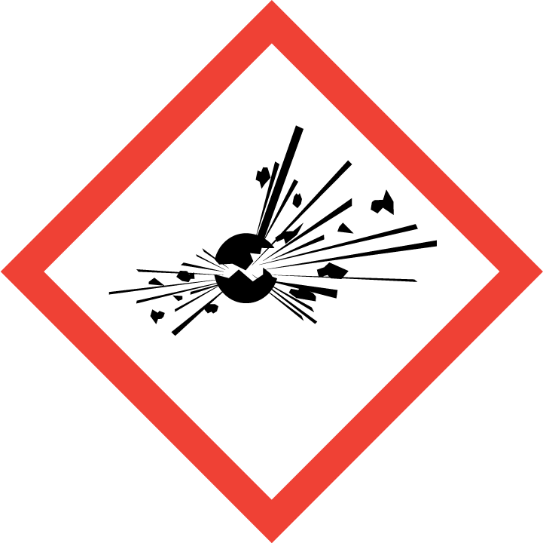
Irritant/Harmful | 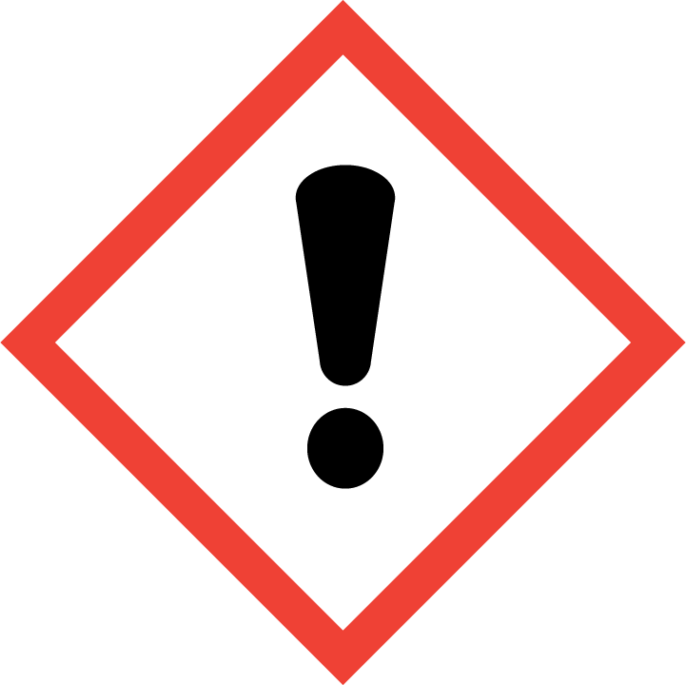
Environment | 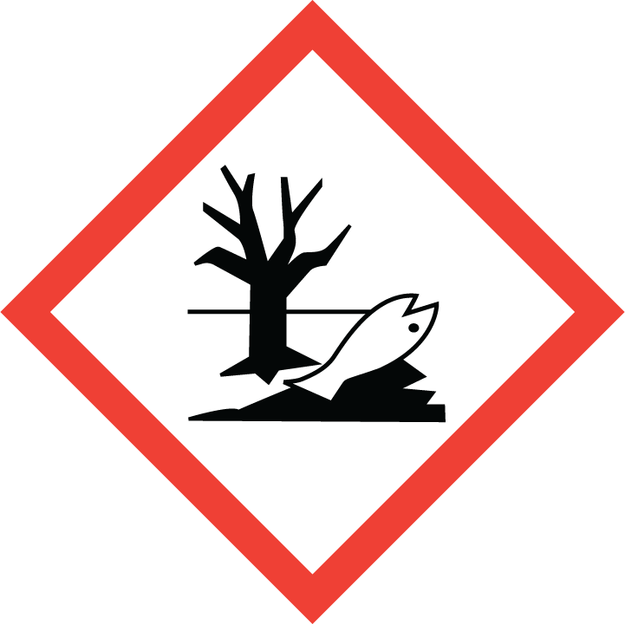
Carcinogenic | 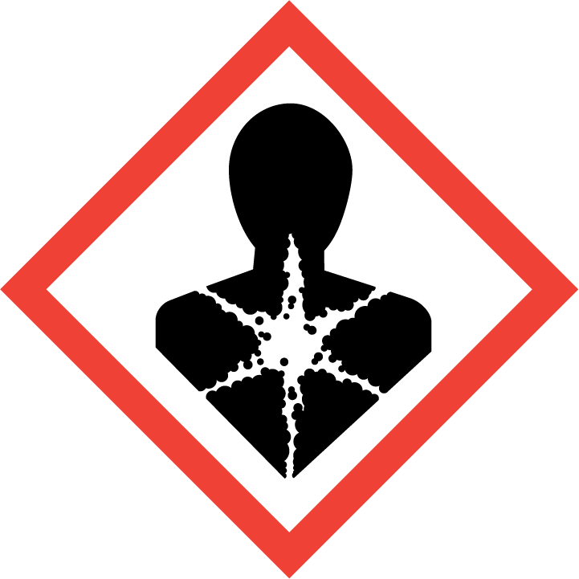
Corrosive | 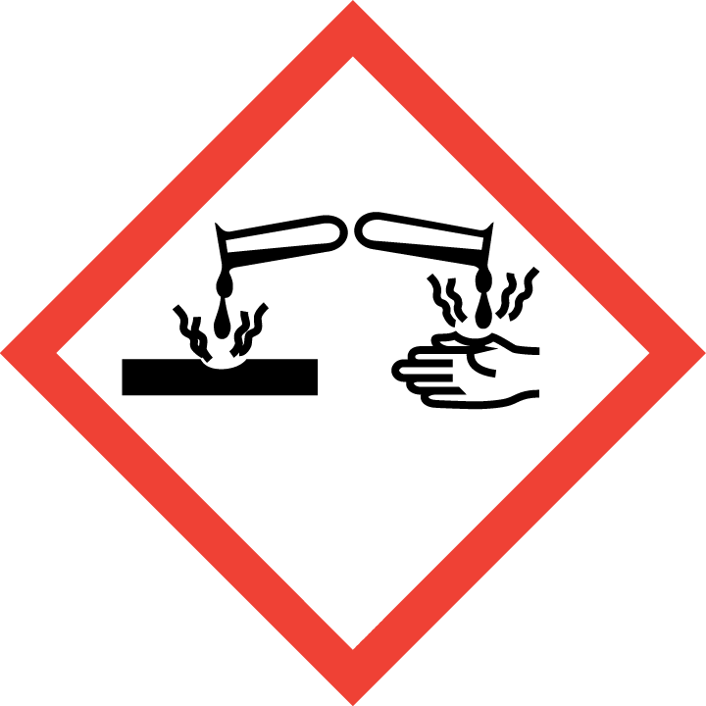
Toxic | 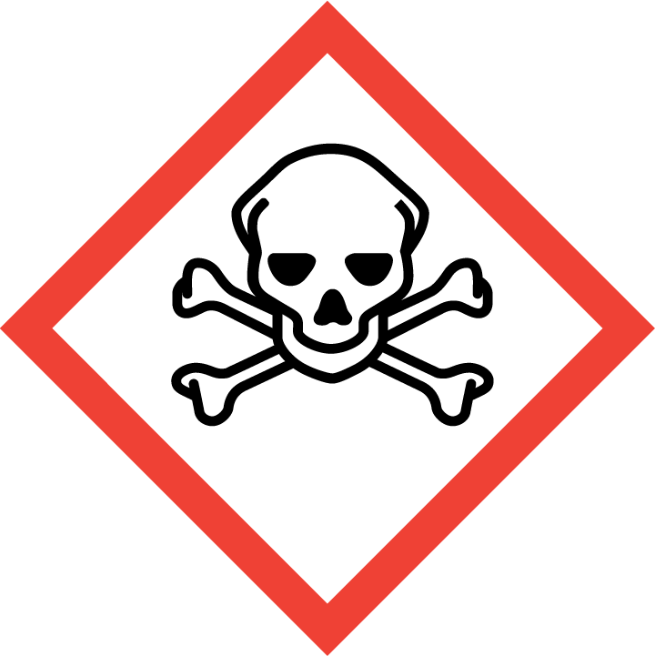
Pressurised | 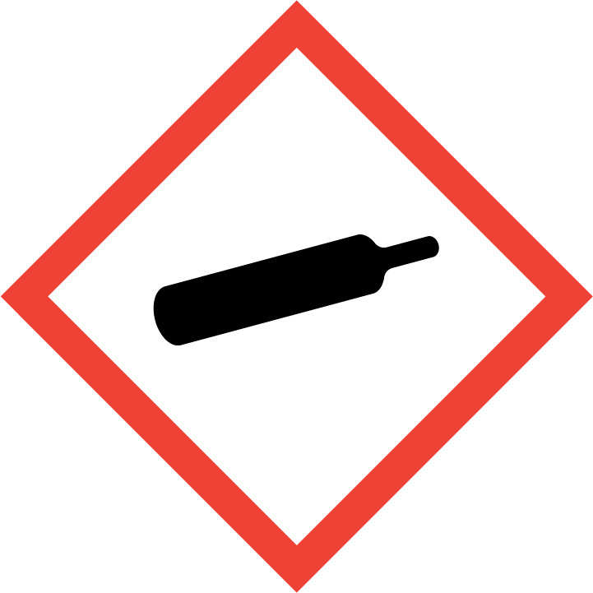
Other – please specify | 

Hazard/Precautionary Statements (must be included)

Hazard Type | Yes/No/Not Applicable (N/A)
Gas
Vapour
Dust
Mist
Fume
Dust
Liquid
Solid
Other – please specify

Route of Exposure | Yes/No/Not Applicable (N/A)
Inhalation
Skin
Eyes
Ingestion
Injection
Other – please specify

Workplace Exposure Limits (WELs) - Please indicate if not applicable (N/A)
Short-term exposure (15 minutes)
Long-term exposure level (8 hour Time Weighted Average (TWA))

Personal Protective Equipment (PPE)
Item | Symbol | If yes – specify type/standard
Air Fed Helmet
Face Visor
Goggles
Safety Glasses
Safety Boots/Shoes
Hand Protection
Overall
Apron
Lab Coat
Half Respirator
Full Respirator
Face Mask
Ventilation | 
Local Exhaust Ventilation | 
Used Outside | 
Other – please specify

First Aid and Emergency Measures
Contact Type | Description of First Aid Measures
Inhaled
Skin Contact
Eye Contact
Swallowed

Emergency Measures | Yes/No/Not Applicable (N/A)
Is health surveillance required?
Is training required for this process?
Fire precautions: What actions will be taken in the event of a fire involving these substance(s)?
How should an accidental release/spillage be dealt with?

Storage, Handling, and Other Information
Handling
Storage

Disposal Method – How should these substances be disposed of (or not disposed of?) | Yes/No/Not Applicable (N/A)
Hazardous waste
Skip
Return to depot
Return to supplier
Other (please state)

Signed
Assessment completed by:
Signature:
Date:

Return to top of document

