Control of Substances Hazardous to Health (COSHH) Risk Assessment Form
Name of substance: | DuoMax General Purpose Cleaner
Other documents to be referenced using this substance: | Refer to Safety Data Sheet  Refer to Manufactures Label
Assessment date: | 07/02/2023
Review date: | 07/02/2026
Describe the activity or work process:  (Include how long and how often this is carried out and the quantity of substance used) | General Purpose Cleaner  Applied according to manufacturers instructions with a cloth. 5ml spray several times a shift.
Identify the persons at risk: (Employees, Contractors, Public, Other – please specify) | Employees, Contractors, Public
Name of the manufacturer/supplier: | DuoTech Holdings Limited Feeder Road  Bristol  BS2 0TH  Telephone: 0845 519 1112  Fax: 0845 519 1113  Emergency Telephone: 0845 519 1112  Out of hours: 07855 845 180
Concentration: | A synergistic blend containing a core biocide, surfactants, complexing agents and alkalis.
(A copy of a current safety data sheet for this substance must be attached to this assessment.)
Contents
Classification (Category of Danger) 1
Personal Protective Equipment (PPE) 2
First Aid and Emergency Measures 3
Storage, Handling, and Other Information 3
Signed 4

Classification (Category of Danger)
Danger | Symbol | Yes/No/Not Applicable (N/A)
Flammable | 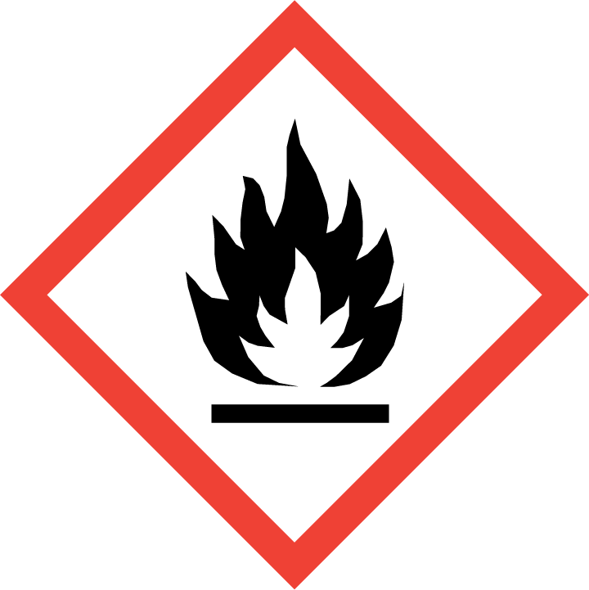 | NO
Oxidising | 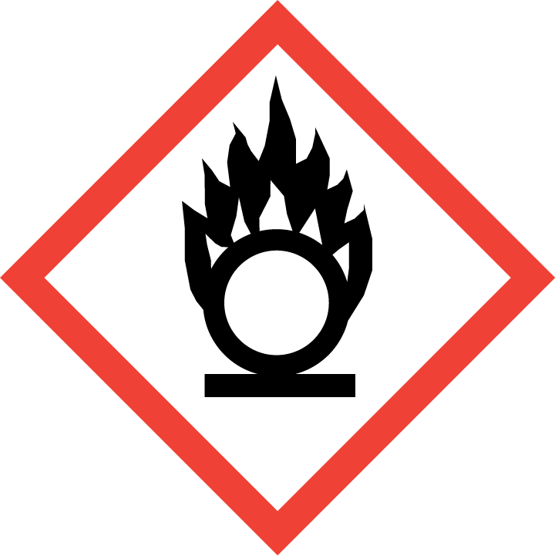 | NO
Explosive | 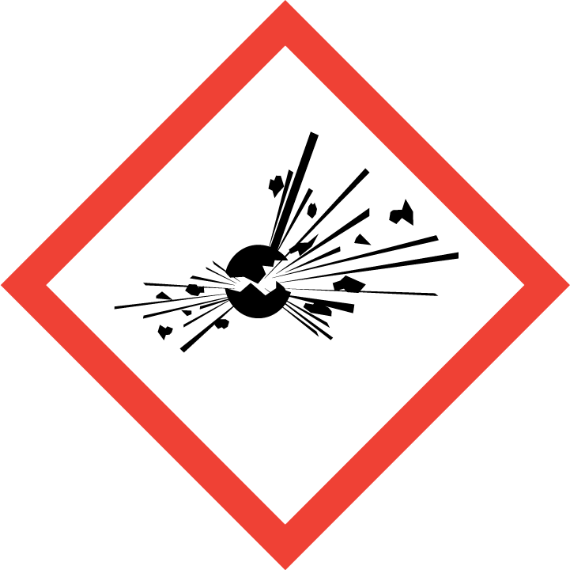 | NO
Irritant/Harmful |  | NO
Environment | 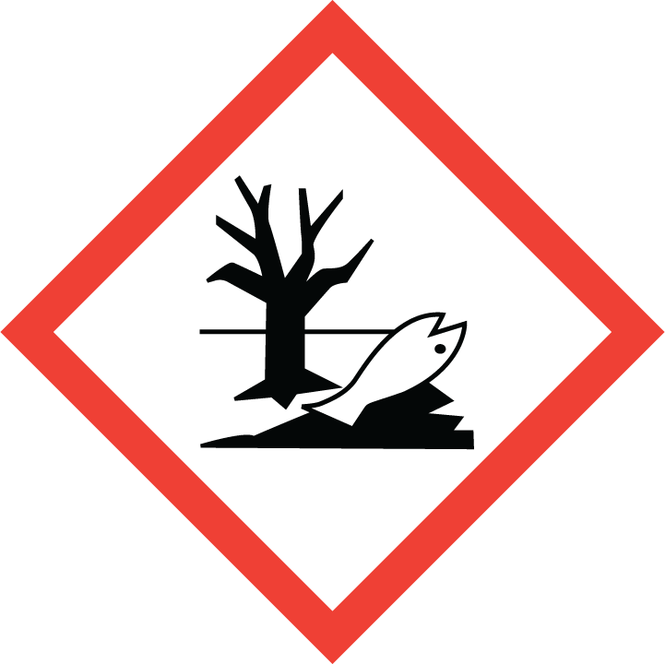 | NO
Carcinogenic | 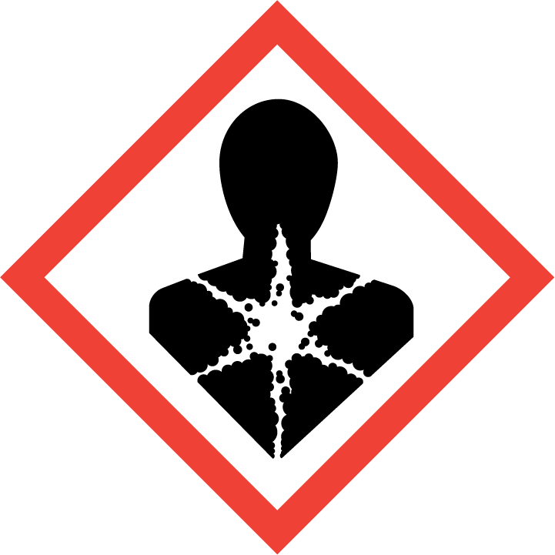 | NO
Corrosive | 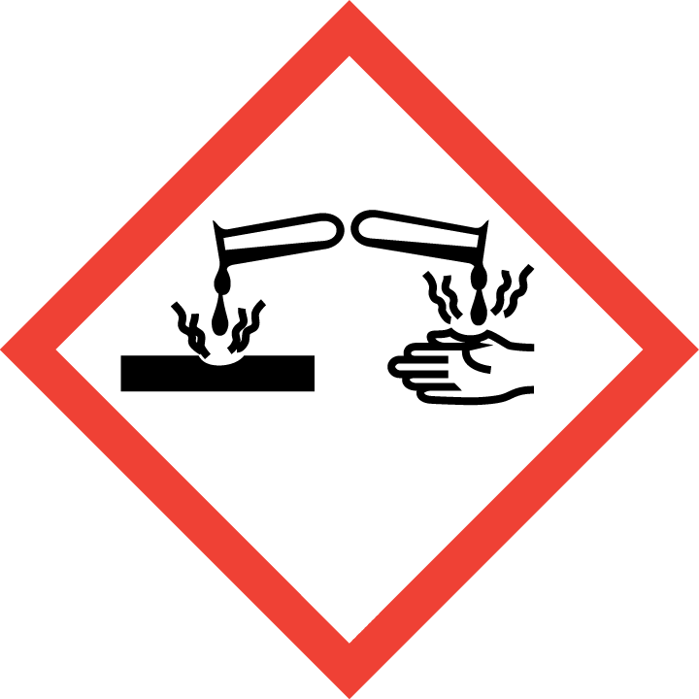 | NO
Toxic | 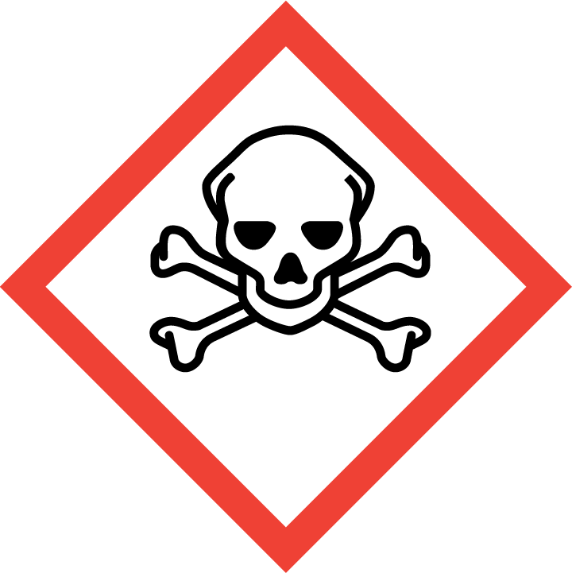 | NO
Pressurised | 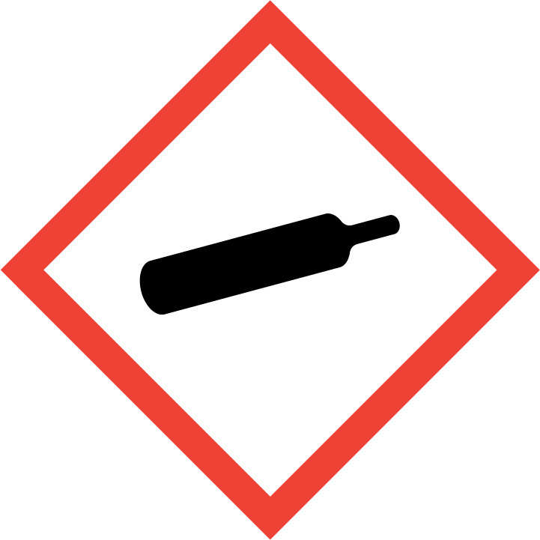 | NO
Other – please specify |  | N/A

Hazard/Precautionary Statements (must be included)
Not Classified

Hazard Type | Yes/No/Not Applicable (N/A)
Gas | No
Vapour | No
Dust | No
Mist | No
Fume | No
Dust | No
Liquid | Yes
Solid | No
Other – please specify | N/A

Route of Exposure | Yes/No/Not Applicable (N/A)
Inhalation | Yes
Skin | Yes
Eyes | Yes
Ingestion | Yes
Injection | No
Other – please specify | N/A

Workplace Exposure Limits (WELs) - Please indicate if not applicable (N/A)
Short-term exposure (15 minutes) | N/A
Long-term exposure level (8 hour Time Weighted Average (TWA)) | N/A

Personal Protective Equipment (PPE)
Item | Symbol | If yes – specify type/standard
Air Fed Helmet
Face Visor
Goggles
Safety Glasses |  | EN166
Safety Boots/Shoes
Hand Protection |  | EN374
Overall
Apron
Lab Coat
Half Respirator
Full Respirator
Face Mask
Ventilation | 
Local Exhaust Ventilation | 
Used Outside | 
Other – please specify |  | Goggles and gloves should be worn for prolonged exposure periods

First Aid and Emergency Measures
Contact Type | Description of First Aid Measures
Inhaled | N/a
Skin Contact | After prolonged use, rinse affected area with water. In the unlikely event of irritation or soreness developing, seek medical advice. Launder contaminated clothing before re-use
Eye Contact | Irrigate with flowing water for at least 15 minutes. Seek medical attention if irritation or soreness persists
Swallowed | Do not induce vomiting, unless instructed to do so by medical personnel. Rinse mouth with water and drink 1 or 2 glasses of water or milk. Seek medical attention.

Emergency Measures | Yes/No/Not Applicable (N/A)
Is health surveillance required? | No
Is training required for this process? | No
Fire precautions: What actions will be taken in the event of a fire involving these substance(s)? | Small Fire: Carbon dioxide, dry chemical powder, alcohol resistant foam or water fog.  Large Fire: Use alcohol resistant foam or water fog.
How should an accidental release/spillage be dealt with? | Absorb with material such as dirt or sand. Remove contaminated material to safe location for subsequent disposal. Small spills may be flushed away with plenty of water

Storage, Handling, and Other Information
Handling | It is advised that gloves be worn if handling the neat product for prolonged periods
Storage | Store in a cool, dry, well-ventilated area, above 0ºC. Avoid exposure to direct sunlight and sources of heat. Keep containers tightly closed when not in use

Disposal Method – How should these substances be disposed of (or not disposed of?) | Yes/No/Not Applicable (N/A)
Hazardous waste | N/A
Skip | N/A
Return to depot | N/A
Return to supplier | N/A
Other (please state) | Dispose of in accordance with local regulations.

Signed
Assessment completed by: | Christopher Moore
Signature: | Cmoore
Date: | 07/02/2023

Return to top of document

