Control of Substances Hazardous to Health (COSHH) Risk Assessment Form
Name of substance: | Glade Pacific Breeze Aerosol
Other documents to be referenced using this substance: | Refer to Safety Data Sheet.
Assessment date: | 07/05/2022
Review date: | 07/05/2025
Describe the activity or work process:  (Include how long and how often this is carried out and the quantity of substance used) | Air care products.
Identify the persons at risk: (Employees, Contractors, Public, Other – please specify) | Employees  Contractors
Name of the manufacturer/supplier: | SC Johnson Professional Glade
Concentration: | Quaternary ammonium compounds, benzyl-C12-16-alkyldimethyl, chlorides>=0.00-<0.10 Butane >=5.00-<10.00  2-methylbutane >=0.00-<0.10 propane-1,2-diol >=0.00-<0.10 1,3-butadiene >=0.00-<0.10
(A copy of a current safety data sheet for this substance must be attached to this assessment.)
Contents
Classification (Category of Danger) 1
Personal Protective Equipment (PPE) 2
First Aid and Emergency Measures 3
Storage, Handling, and Other Information 3
Signed 4

Classification (Category of Danger)
Danger | Symbol | Yes/No/Not Applicable (N/A)
Flammable | 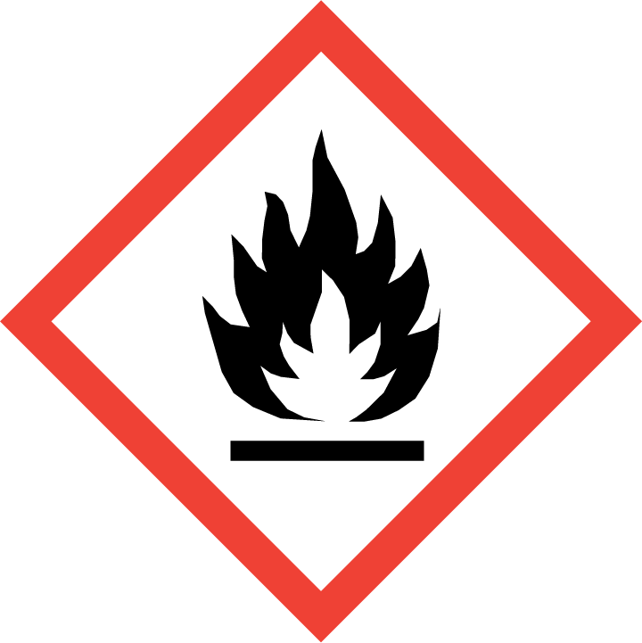 | Yes
Oxidising | 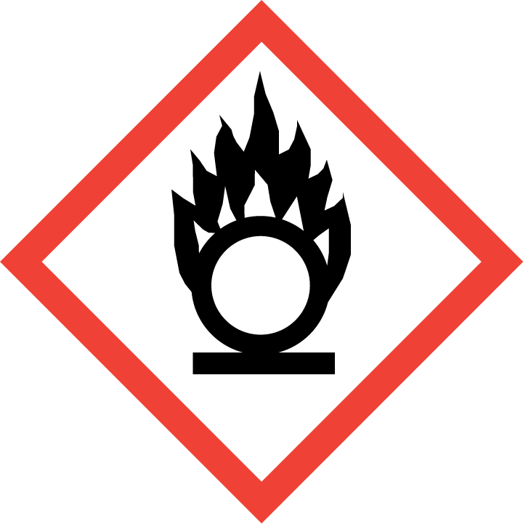
Explosive | 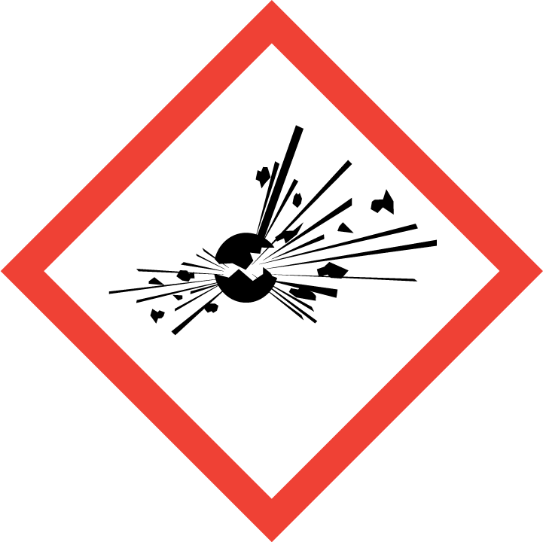
Irritant/Harmful | 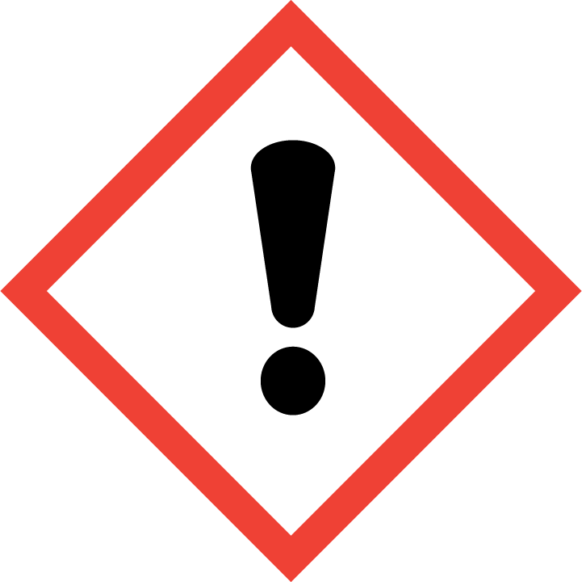
Environment | 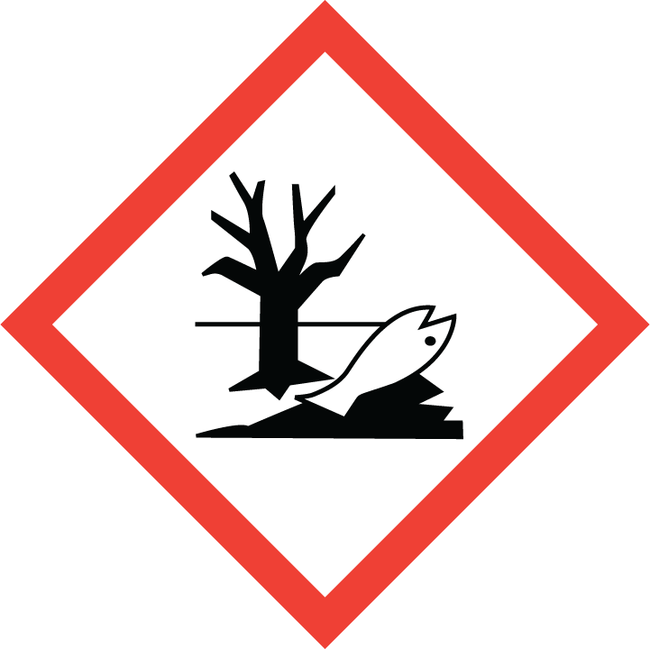
Carcinogenic | 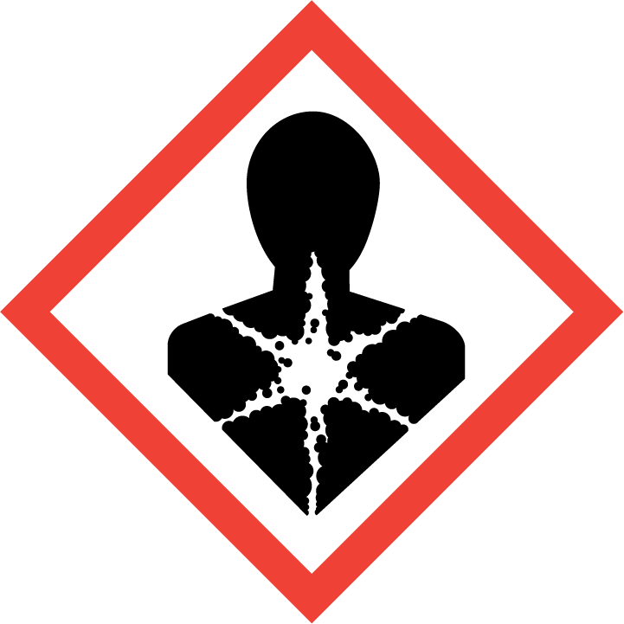
Corrosive | 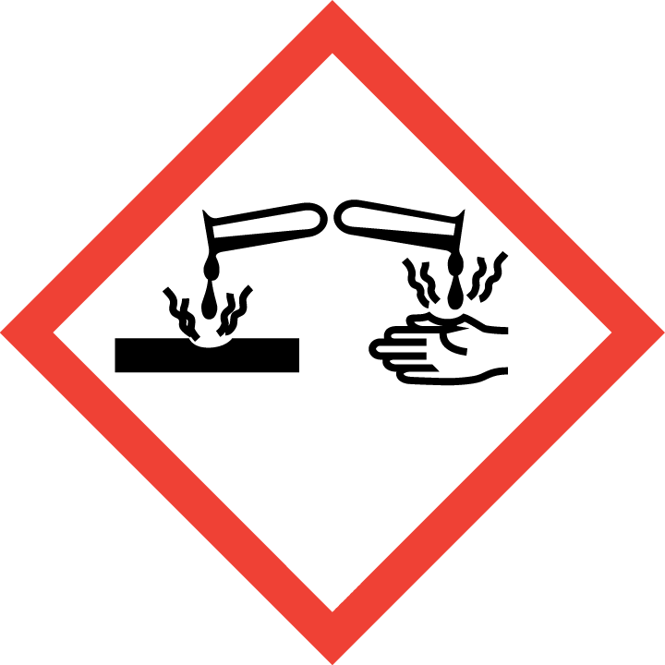
Toxic | 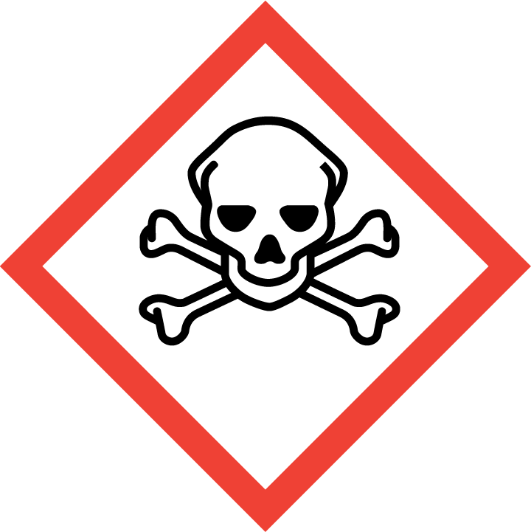
Pressurised | 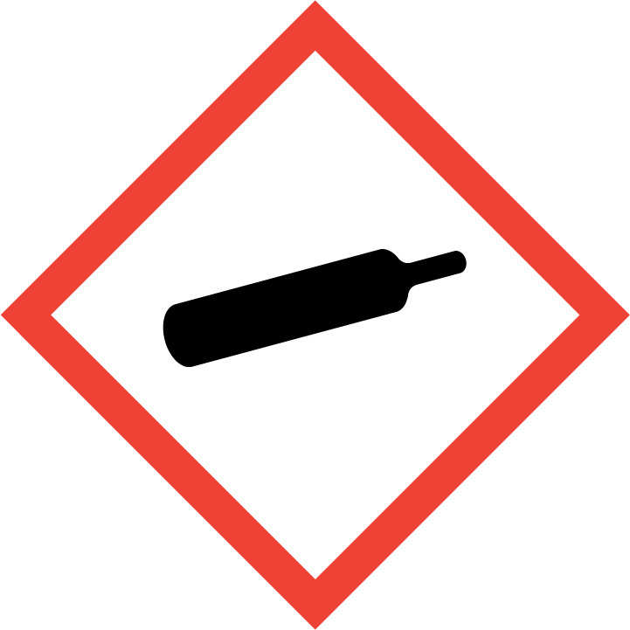
Other – please specify | 

Hazard/Precautionary Statements (must be included)
H223: Flammable aerosol
H229: Pressurised container: may burst if heated.
P102: Keep out of reach of children.
P410+P412: Protect from sunlight. Do not expose to temperatures exceeding 50.C/122F.
P210: Keep away from heat, hot surfaces, sparks, open flames and other ignition sources. No smoking.
P211: Do not spray and open flame
P251: Do not pierce or burn, even after use

Hazard Type | Yes/No/Not Applicable (N/A)
Gas
Vapour
Dust
Mist
Fume
Dust
Liquid
Solid
Other – please specify | Aerosol

Route of Exposure | Yes/No/Not Applicable (N/A)
Inhalation | Yes
Skin | Yes
Eyes | Yes
Ingestion | Yes
Injection
Other – please specify

Workplace Exposure Limits (WELs) - Please indicate if not applicable (N/A)
Short-term exposure (15 minutes) | N/A
Long-term exposure level (8 hour Time Weighted Average (TWA)) | N/A

Personal Protective Equipment (PPE)
Item | Symbol | If yes – specify type/standard
Air Fed Helmet
Face Visor
Goggles
Safety Glasses
Safety Boots/Shoes
Hand Protection |  | Yes- Nitrile gloves
Overall
Apron
Lab Coat
Half Respirator
Full Respirator
Face Mask
Ventilation | 
Local Exhaust Ventilation | 
Used Outside | 
Other – please specify

First Aid and Emergency Measures
Contact Type | Description of First Aid Measures
Inhaled | Move to fresh air.  If breathing is affected, get medical attention.
Skin Contact | Rinse with plenty of water.  Get medical attention if irritation develops and persists.
Eye Contact | Rinse with plenty of water.  Get medical attention if irritation develops and persists.
Swallowed | If symptoms persist, call a physician.

Emergency Measures | Yes/No/Not Applicable (N/A)
Is health surveillance required? | No
Is training required for this process? | No
Fire precautions: What actions will be taken in the event of a fire involving these substance(s)? | Use extinguishing measures that are appropriate to local circumstances  and the surrounding environment.  Heating may cause an explosion.  In case of fire and/or explosion do not breathe fumes.  Exposure to decomposition products may be a hazard to health.  In the event of fire, wear self-contained breathing apparatus.  Wear suitable protective clothing and gloves.  Refer to current EN or National standard as appropriate.
How should an accidental release/spillage be dealt with? | Use personal protective equipment.  Remove all sources of ignition.  Beware of vapours accumulating to form explosive concentrations. Vapours  can accumulate in low areas.  Outside of normal use, avoid release to the environment.  Prevent large amounts of product from entering drains.  Do not flush into surface water or sanitary sewer system.  Use appropriate containment to avoid environmental contamination.  If damage occurs to aerosol can:  Contain spillage, and then collect with non-combustible absorbent material,  (e.g. sand, earth, diatomaceous earth, vermiculite) and place in container  for disposal according to local/national regulations.  Clean residue from spill site.  Dike large spills.  Use only non-sparking equipment.

Storage, Handling, and Other Information
Handling | Do not breathe vapours or spray mist.  Do not use in areas without adequate ventilation.  Do not puncture.  Use explosion-proof equipment.  Keep away from sources of ignition - No smoking.  Do not spray on a naked flame or any incandescent material.  Take measures to prevent the build up of electrostatic charge.
Storage | No smoking.  Store in cool place.  Do not freeze.  Pressurized container: protect from sunlight and do not expose to  temperatures exceeding 50 °C. Do not pierce or burn, even after use.  Keep out of the reach of children.  No decomposition if stored and applied as directed.

Disposal Method – How should these substances be disposed of (or not disposed of?) | Yes/No/Not Applicable (N/A)
Hazardous waste
Skip
Return to depot
Return to supplier
Other (please state) | Do not dispose of waste into sewer.  Do not contaminate ponds, waterways or ditches with chemical or used container.  Disposal should be in accordance with local, state or national legislation.  Please recycle empty packaging.  Do not re-use empty containers.

Signed
Assessment completed by: | The CoSHH Group
Signature: | The CoSHH Group
Date: | 07/05/2022

Return to top of document

