Control of Substances Hazardous to Health (COSHH) Risk Assessment Form
Name of substance: | Gum Free
Other documents to be referenced using this substance: | Safety Data Sheet
Assessment date: | 13/6/23
Review date: | 13/6/26
Describe the activity or work process:  (Include how long and how often this is carried out and the quantity of substance used) | Refer to manufacturers Data sheet
Identify the persons at risk: (Employees, Contractors, Public, Other – please specify) | Employees
Name of the manufacturer/supplier: | Aztec Chemicals
Concentration: | Aerosol
(A copy of a current safety data sheet for this substance must be attached to this assessment.)
Contents
Classification (Category of Danger) 1
Personal Protective Equipment (PPE) 2
First Aid and Emergency Measures 3
Storage, Handling, and Other Information 3
Signed 4

Classification (Category of Danger)
Danger | Symbol | Yes/No/Not Applicable (N/A)
Flammable | 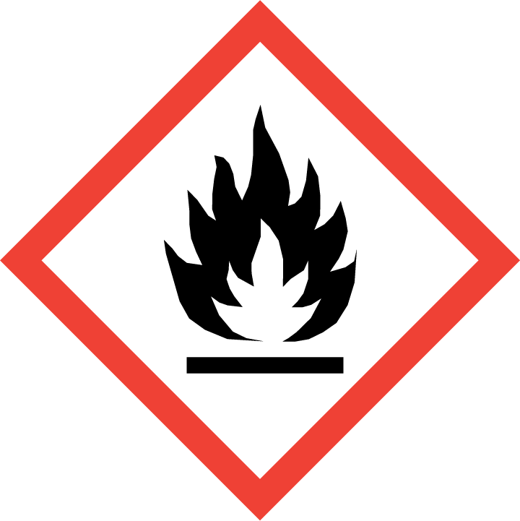 | Yes
Oxidising | 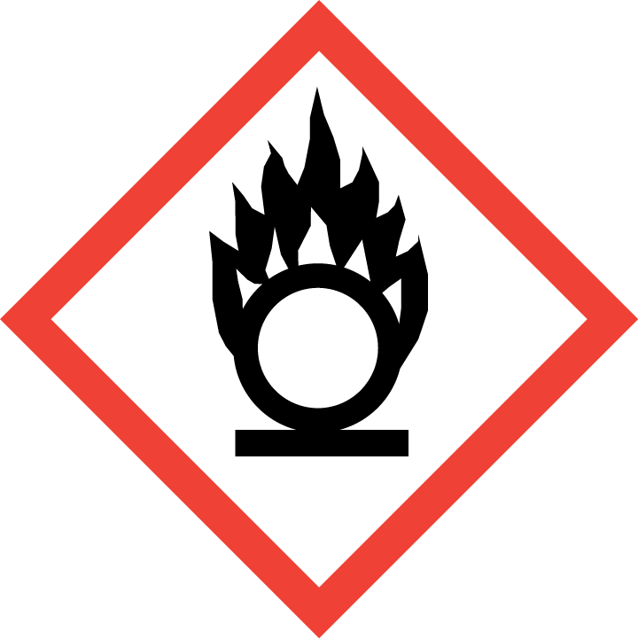 | No
Explosive | 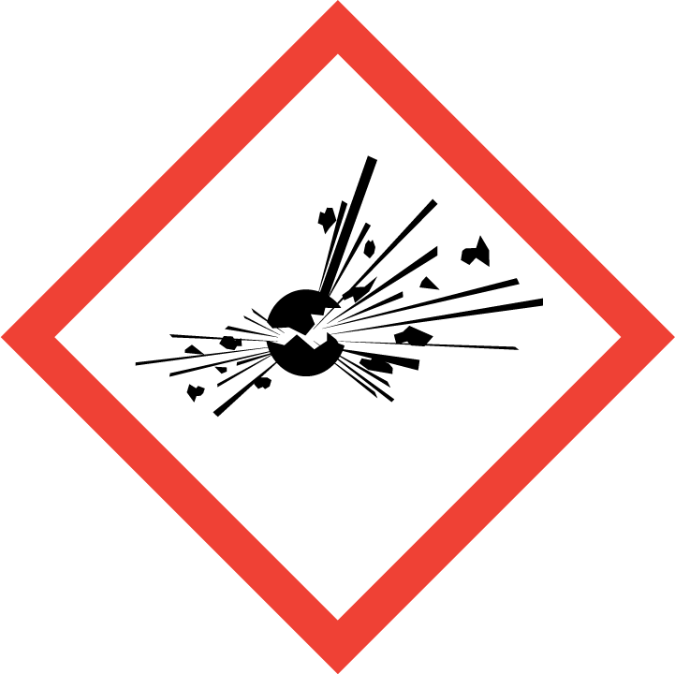 | Yes
Irritant/Harmful | 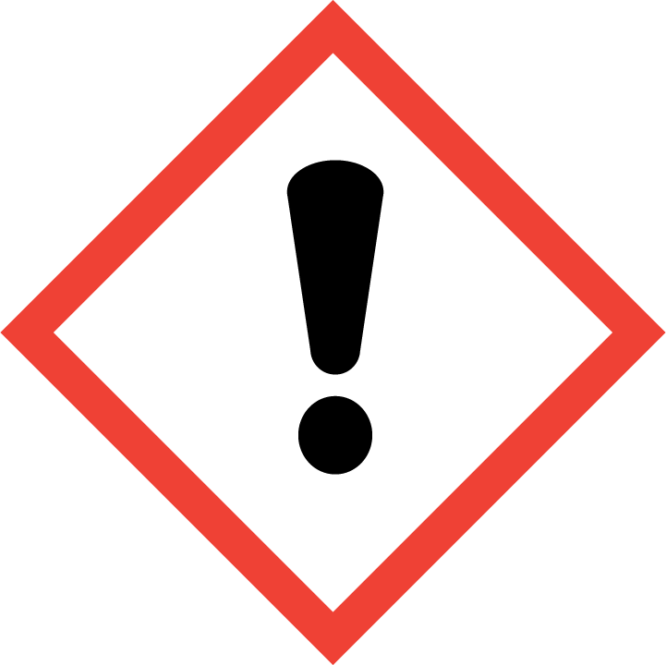 | Yes
Environment | 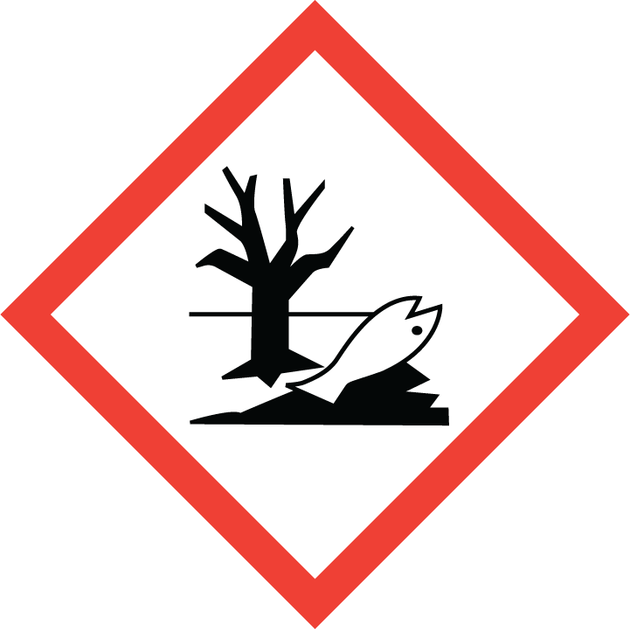 | No
Carcinogenic | 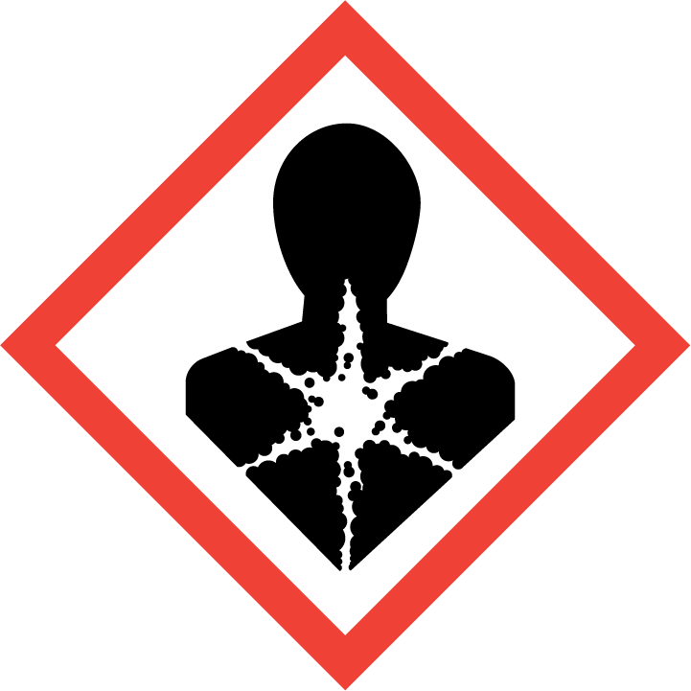 | No
Corrosive | 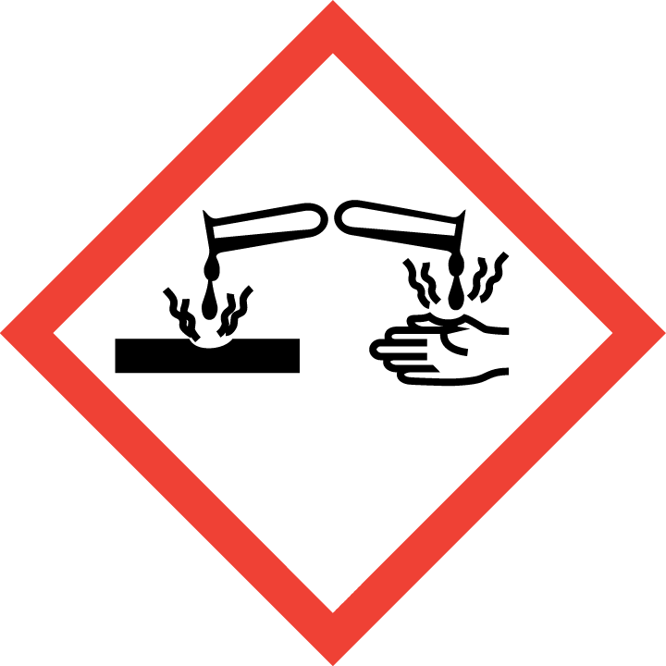 | No
Toxic | 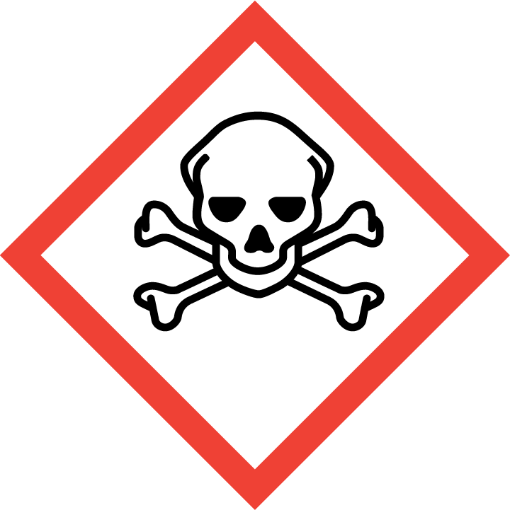 | Yes
Pressurised | 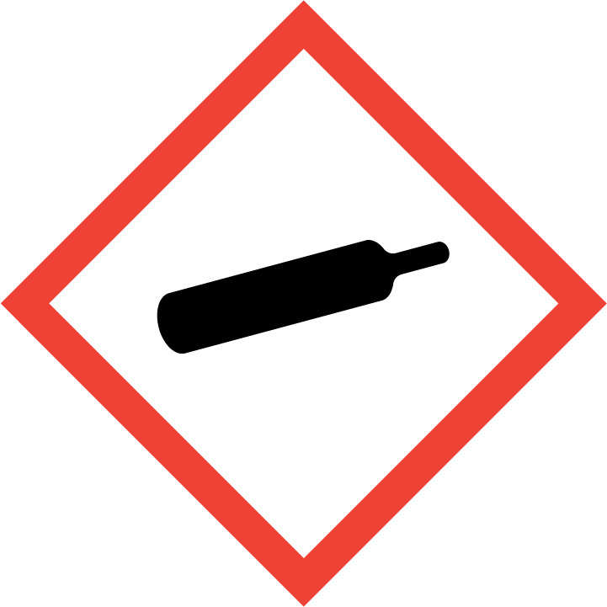 | Yes
Other – please specify | 

Hazard/Precautionary Statements (must be included)
H229 Pressurised container: may burst if heated
P102 Keep out of reach of children. P501 Dispose of contents/container in accordance with local regulations. P410+P412 Protect from sunlight. Do not expose to temperatures exceeding 50°C/122°F. P210 Keep away from heat, hot surfaces, sparks, open flames and other ignition sources. No smoking. P251 Do not pierce or burn, even after use. P260 Do not breathe vapour/spray. P271 Use only outdoors or in a well-ventilated area.

Hazard Type | Yes/No/Not Applicable (N/A)
Gas | Yes
Vapour | Yes
Dust | No
Mist | No
Fume | Yes
Dust | No
Liquid | Yes
Solid | N/A
Other – please specify

Route of Exposure | Yes/No/Not Applicable (N/A)
Inhalation | Yes
Skin | Yes
Eyes | Yes
Ingestion | Yes
Injection | No
Other – please specify

Workplace Exposure Limits (WELs) - Please indicate if not applicable (N/A)
Short-term exposure (15 minutes)
Long-term exposure level (8 hour Time Weighted Average (TWA)) | N/A

Personal Protective Equipment (PPE)
Item | Symbol | If yes – specify type/standard
Air Fed Helmet
Face Visor
Goggles |  | Chemical splash goggles
Safety Glasses
Safety Boots/Shoes
Hand Protection |  | Chemical-resistant, impervious gloves
Overall
Apron
Lab Coat
Half Respirator
Full Respirator
Face Mask
Ventilation |  | Yes
Local Exhaust Ventilation | 
Used Outside | 
Other – please specify

First Aid and Emergency Measures
Contact Type | Description of First Aid Measures
Inhaled | Move affected person to fresh air at once. If breathing stops, provide artificial respiration. Keep affected person warm and at rest. Get medical attention immediately
Skin Contact | Rinse with water. Get medical attention if irritation persists after washing
Eye Contact | Rinse with water. Get medical attention if any discomfort continues.
Swallowed | Rinse mouth thoroughly with water.

Emergency Measures | Yes/No/Not Applicable (N/A)
Is health surveillance required?
Is training required for this process? | Refer to manufacturers instructions
Fire precautions: What actions will be taken in the event of a fire involving these substance(s)? | Warn firefighters that aerosols are involved. Containers close to fire should be removed or cooled with water.
How should an accidental release/spillage be dealt with? | VENTILATE/EVAPORATE.

Storage, Handling, and Other Information
Handling | Read and follow manufacturer's recommendations. Do not spray near a naked flame or any incandescent material.
Storage | Pressurised container: protect from sunlight and do not expose to temperatures exceeding 50 degrees Centigrade. Do not pierce or burn, even after use

Disposal Method – How should these substances be disposed of (or not disposed of?) | Yes/No/Not Applicable (N/A)
Hazardous waste
Skip
Return to depot | Dispose of waste to licensed waste disposal site in accordance with the requirements of the local Waste Disposal Authority.
Return to supplier
Other (please state)

Signed
Assessment completed by: | Gillian Smith-Ward
Signature: | 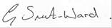
Date: | 13/6/23

Return to top of document

