Control of Substances Hazardous to Health (COSHH) Risk Assessment Form
Name of substance: | Lifeguard 3 in 1 Toilet Cleaner
Other documents to be referenced using this substance: | Safety Data Sheet  Manufacturers Label
Assessment date: | 03/03/2023
Review date: | 03/03/2026
Describe the activity or work process:  (Include how long and how often this is carried out and the quantity of substance used) | Use direct from bottle to toilet do not dilute.
Identify the persons at risk: (Employees, Contractors, Public, Other – please specify) | Employees
Name of the manufacturer/supplier: | Deb Ltd  Denby Hall Way  Denby  Derbyshire  DE5 8JZ  Tel. 01773 855105  Email reach@deb.co.uk
Concentration: | Phosphoric Acid 1-5%  Alcohol Ethoxylate 1-5%  Alkyl Benzyl Dimethyl Ammonium Chloride <1%
(A copy of a current safety data sheet for this substance must be attached to this assessment.)
Contents
Classification (Category of Danger) 1
Personal Protective Equipment (PPE) 2
First Aid and Emergency Measures 3
Storage, Handling, and Other Information 3
Signed 4

Classification (Category of Danger)
Danger | Symbol | Yes/No/Not Applicable (N/A)
Flammable | 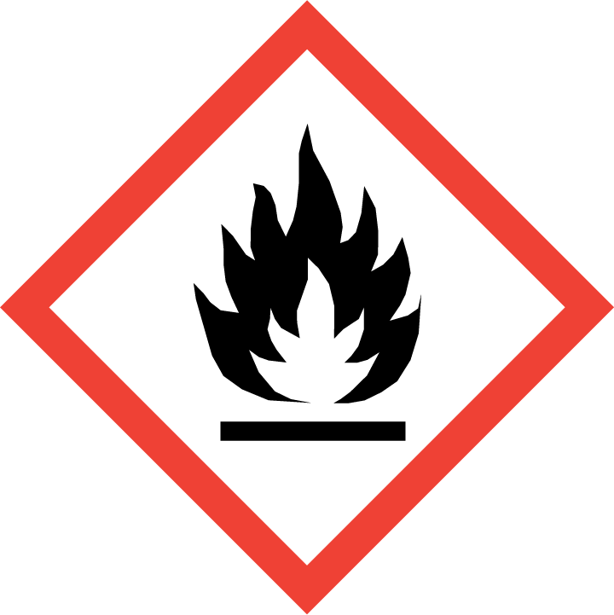
Oxidising | 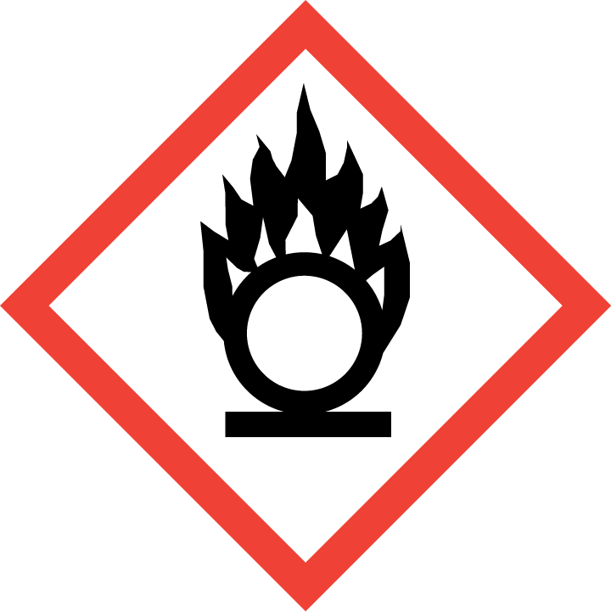
Explosive | 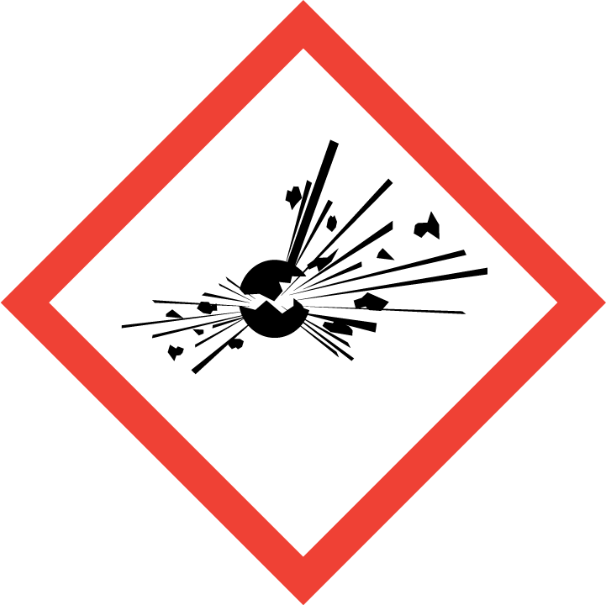
Irritant/Harmful | 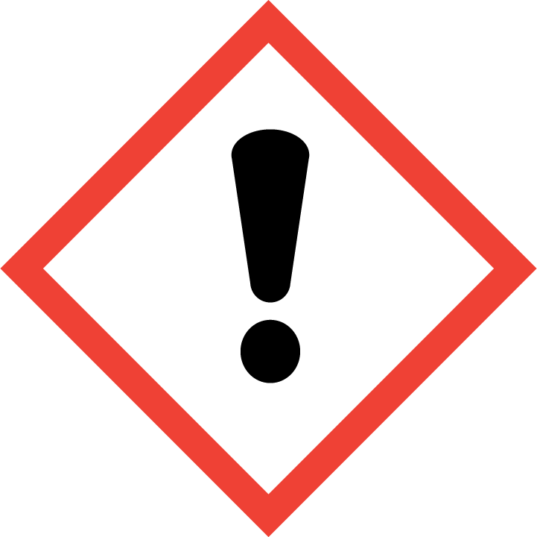
Environment | 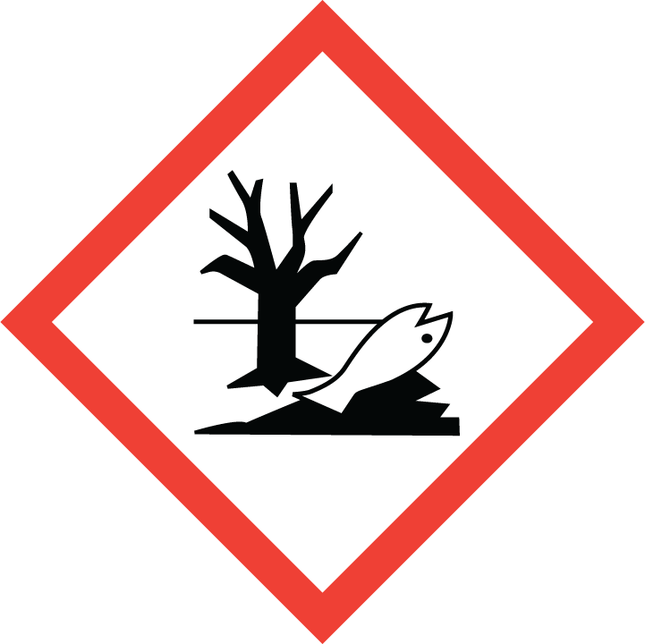
Carcinogenic | 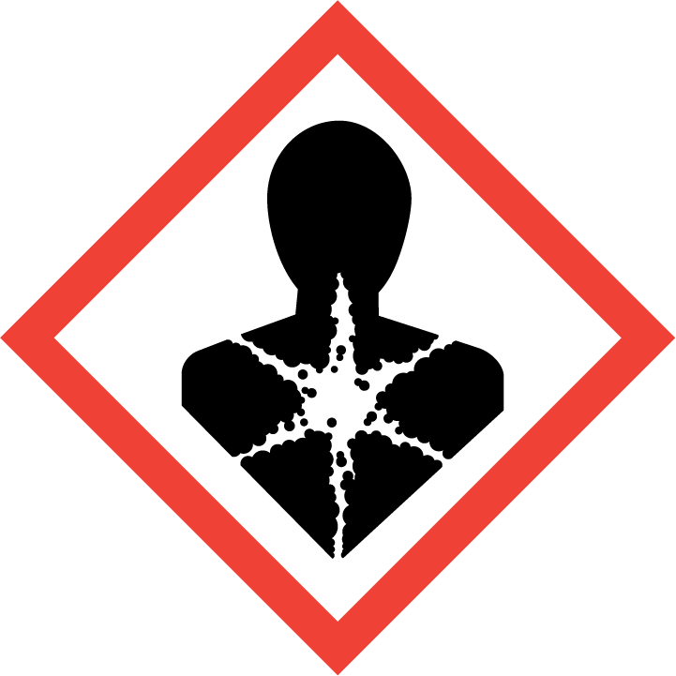
Corrosive | 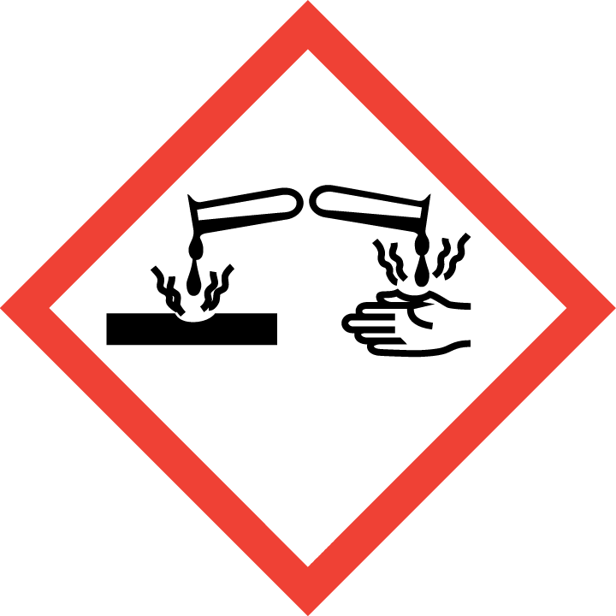 | Yes
Toxic | 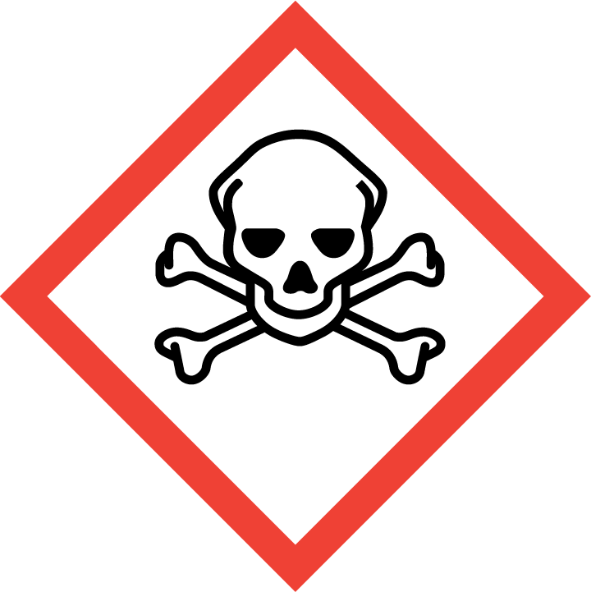
Pressurised | 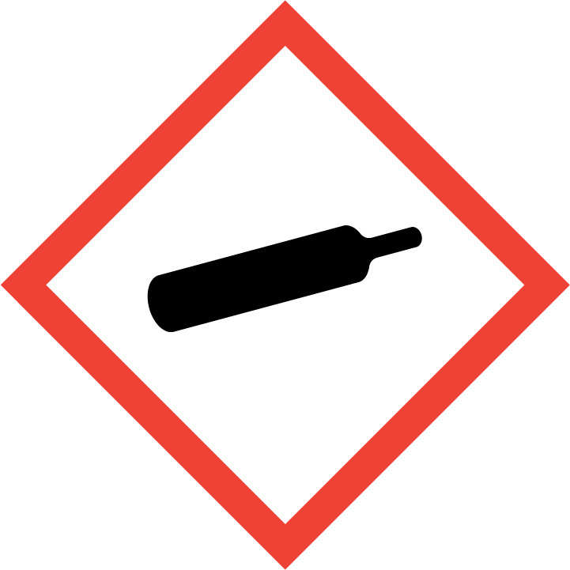
Other – please specify | 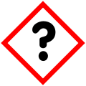

Hazard/Precautionary Statements (must be included)
Causes severe skin burns and eye damage.
Causes serious eye irritation.
Harmful to aquatic life with long lasting effects.
Wear protective clothing, gloves, eye and face protection.

Hazard Type | Yes/No/Not Applicable (N/A)
Gas
Vapour
Dust
Mist
Fume
Dust
Liquid | Yes
Solid
Other – please specify

Route of Exposure | Yes/No/Not Applicable (N/A)
Inhalation | Yes
Skin | Yes
Eyes | Yes
Ingestion | Yes
Injection
Other – please specify

Workplace Exposure Limits (WELs) - Please indicate if not applicable (N/A)
Short-term exposure (15 minutes) | n/a
Long-term exposure level (8 hour Time Weighted Average (TWA)) | n/a

Personal Protective Equipment (PPE)
Item | Symbol | If yes – specify type/standard
Air Fed Helmet
Face Visor
Goggles |  | Yes EN166
Safety Glasses |  | Yes EN166
Safety Boots/Shoes
Hand Protection |  | Yes EN374
Overall
Apron
Lab Coat
Half Respirator
Full Respirator
Face Mask
Ventilation | 
Local Exhaust Ventilation | 
Used Outside | 
Other – please specify

First Aid and Emergency Measures
Contact Type | Description of First Aid Measures
Inhaled | Move affected person to fresh air and keep warm and at rest in a comfortable position for breathing. Get medical attention if any discomfort continues.
Skin Contact | Remove person from the source of contamination. Remove contaminated clothing. Wash skin thoroughly with soap and water. Get medical attention promptly if symptoms occur after washing.
Eye Contact | Remove person from source of contamination. Remove contact lenses and open eyelids wide apart. Continue to rinse for at least 15 minutes. Get medical attention immediately. Continue to rinse.
Swallowed | Never give anything by mouth to an unconscious person. If swallowed rinse mouth thoroughly with water. Do NOT induce vomiting. Get medical attention immediately.

Emergency Measures | Yes/No/Not Applicable (N/A)
Is health surveillance required? | n/a
Is training required for this process? | n/a
Fire precautions: What actions will be taken in the event of a fire involving these substance(s)? | This product is not flammable. Use fire-extinguishing media suitable for the surrounding fire.
How should an accidental release/spillage be dealt with? | Wear protective clothing.  Do not touch or walk into the spilled material stop leak if possible without risk. Absorb in vermiculite, dry sand or earth and place into containers. Flush contaminated area with plenty of water.  Avoid discharge to the aquatic environment. The product may affect the acidity of water which may have hazardous effects on aquatic organisms. Collect and dispose of spillage in accordance with the requirements of the local waste disposal authority.

Storage, Handling, and Other Information
Handling | Avoid spilling. Avoid contact with skin and eyes.  Do not eat, smoke or drink when using this product.  Promptly remove any clothing that becomes contaminated.
Storage | Store in closed original container at temperatures between 0 - 30 degrees C  Keep away from children and food.

Disposal Method – How should these substances be disposed of (or not disposed of?) | Yes/No/Not Applicable (N/A)
Hazardous waste
Skip
Return to depot
Return to supplier
Other (please state) | Residues and empty containers should be taken care of as hazardous waste according to local and national provisions.

Signed
Assessment completed by: | Kathryn Elliott
Signature: | 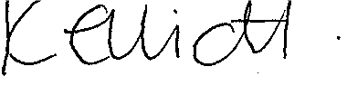
Date: | 03/03/2023

Return to top of document

