Control of Substances Hazardous to Health (COSHH) Risk Assessment Form
Name of substance: | Sprint Cream Cleaner
Other documents to be referenced using this substance: | Refer to Safety Data Sheet.
Assessment date: | 05/05/2022
Review date: | 05/05/2025
Describe the activity or work process:  (Include how long and how often this is carried out and the quantity of substance used) | General purpose cleaner – hand applied onto surface with cloth
Identify the persons at risk: (Employees, Contractors, Public, Other – please specify) | Employees  Contractors  Members of Public
Name of the manufacturer/supplier: | Diversey ltd.
Concentration: | Calcium carbonate 30-50%  Sulphonic acids, C14-17-sec-alkane, sodium salta 3-10%  Alkyl alcohol ethoxylate 1-3%  Gultaral 0.01-0.1%  1,2-benzisithiazol-3(2H)-one <0.01
(A copy of a current safety data sheet for this substance must be attached to this assessment.)
Contents
Classification (Category of Danger) 1
Personal Protective Equipment (PPE) 2
First Aid and Emergency Measures 3
Storage, Handling, and Other Information 3
Signed 4

Classification (Category of Danger)
Danger | Symbol | Yes/No/Not Applicable (N/A)
Flammable | 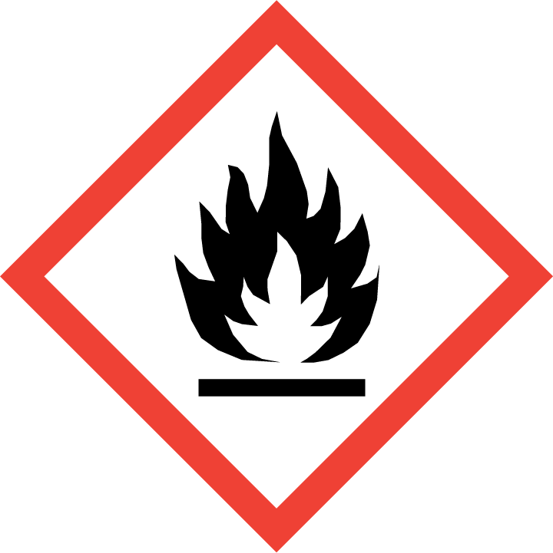
Oxidising | 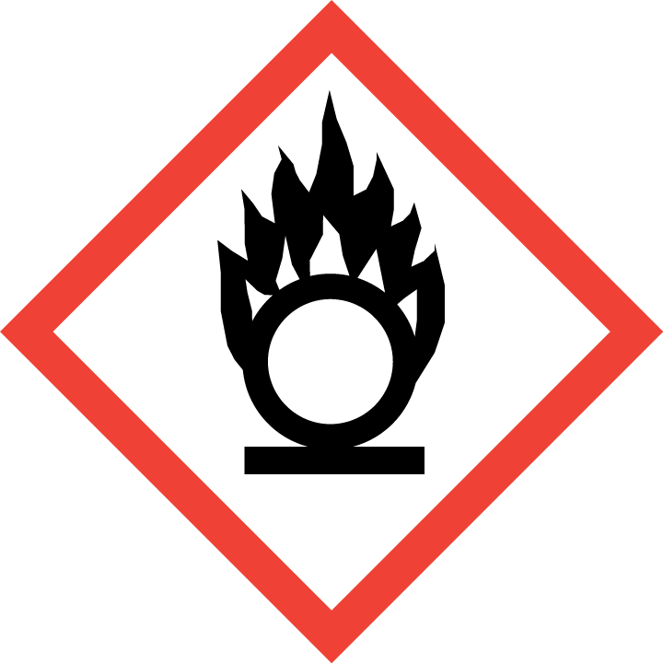
Explosive | 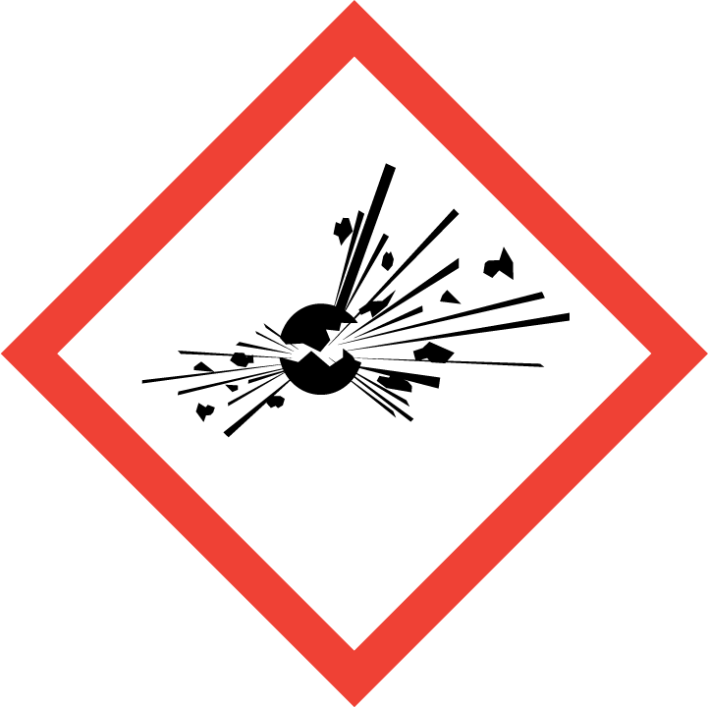
Irritant/Harmful | 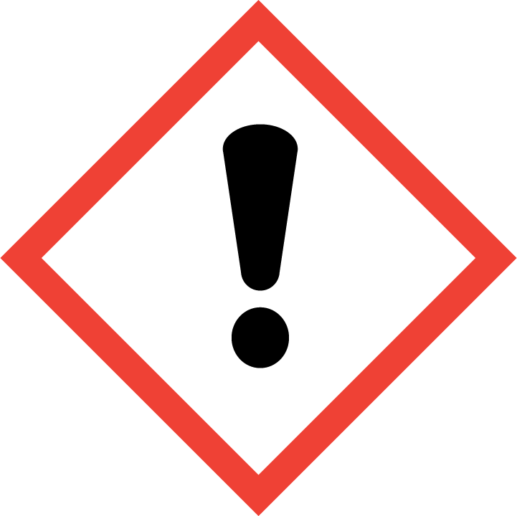 | Yes
Environment | 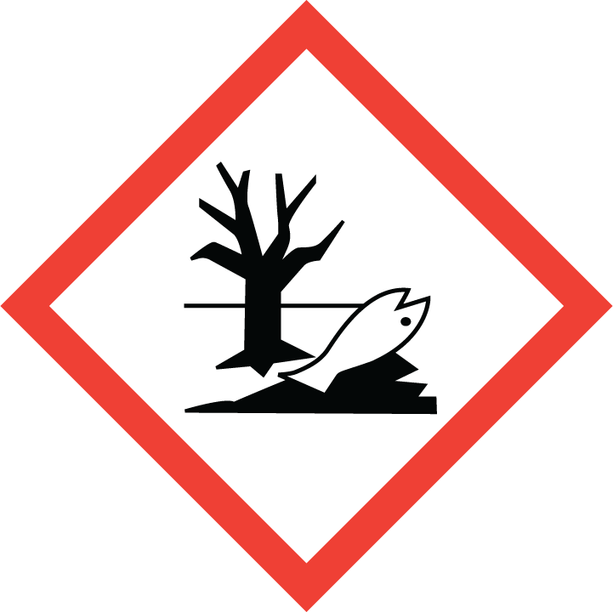
Carcinogenic | 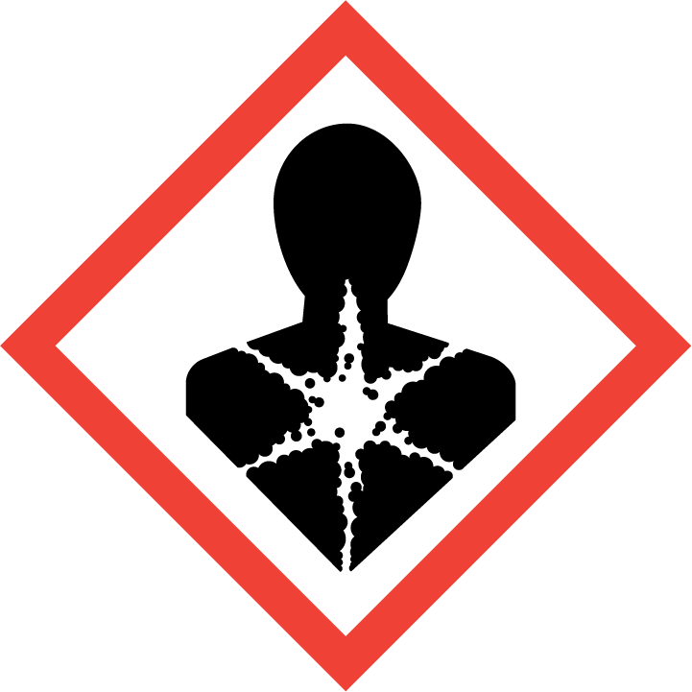
Corrosive | 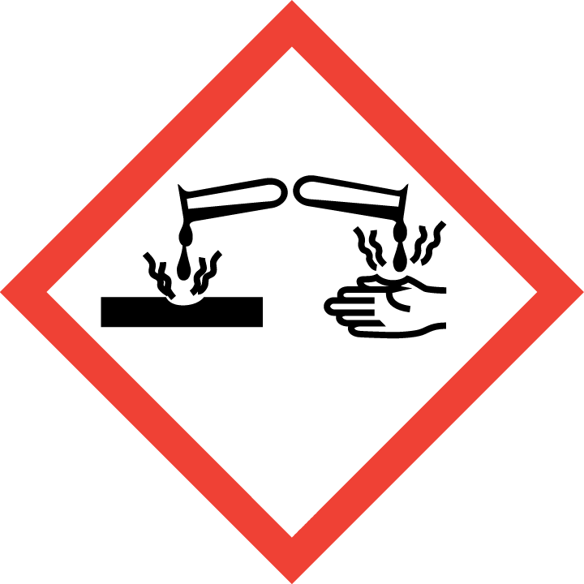
Toxic | 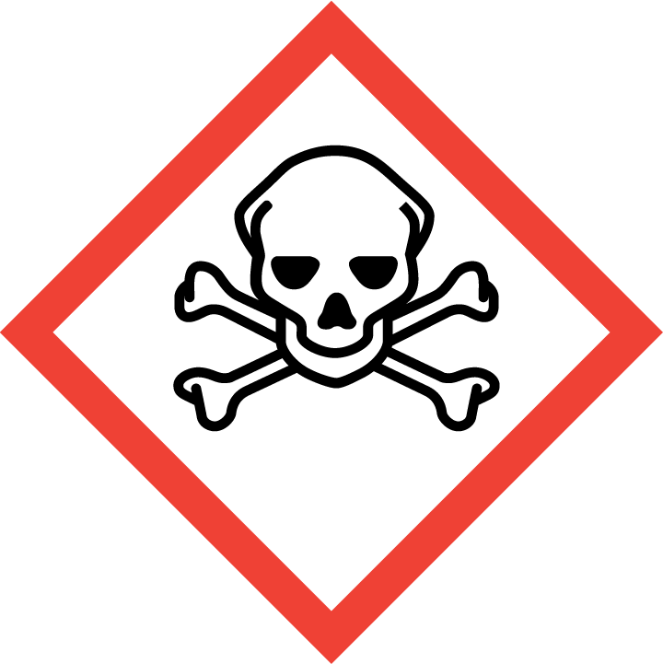
Pressurised | 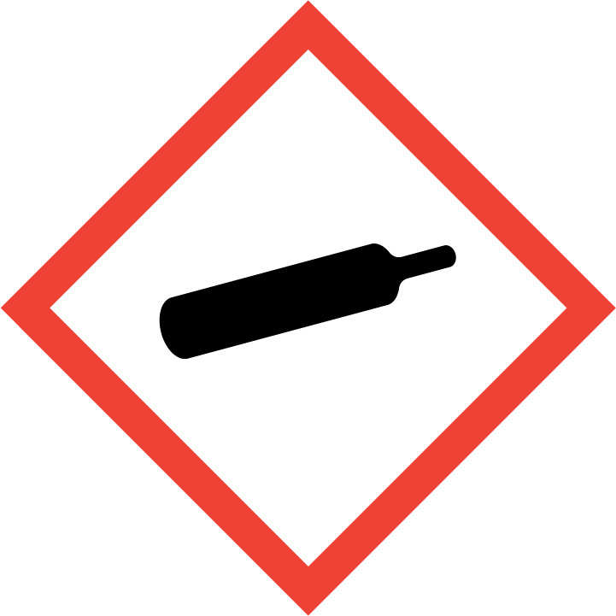
Other – please specify | 

Hazard/Precautionary Statements (must be included)
Signal Word: WARNING

H319: Causes serious eye irritation.

Hazard Type | Yes/No/Not Applicable (N/A)
Gas
Vapour
Dust
Mist
Fume
Dust
Liquid | Yes
Solid
Other – please specify

Route of Exposure | Yes/No/Not Applicable (N/A)
Inhalation | Yes
Skin | Yes
Eyes | Yes
Ingestion | Yes
Injection
Other – please specify

Workplace Exposure Limits (WELs) - Please indicate if not applicable (N/A)
Short-term exposure (15 minutes) | Calcium carbonate:  Inhalable dust: 30mg/m3  Respirable dust: 12mg/m3  Glutaral: 0.05 ppm/0.2 mg/m3
Long-term exposure level (8 hour Time Weighted Average (TWA)) | Calcium carbonate:  Inhalable dust: 10mg/m3  Respirable dust: 4mg/m3  Glutaral: 0.05 ppm/0.2 mg/m3

Personal Protective Equipment (PPE)
Item | Symbol | If yes – specify type/standard
Air Fed Helmet
Face Visor
Goggles
Safety Glasses |  | Yes – EN166 if splashes are likely
Safety Boots/Shoes
Hand Protection |  | Yes – EN374 Nitrile
Overall
Apron
Lab Coat
Half Respirator
Full Respirator
Face Mask
Ventilation | 
Local Exhaust Ventilation | 
Used Outside | 
Other – please specify

First Aid and Emergency Measures
Contact Type | Description of First Aid Measures
Inhaled | Get medical attention or advice if you feel unwell.
Skin Contact | Wash skin with plenty of lukewarm, gently flowing water. If skin irritation occurs: Get medical advice or attention.
Eye Contact | Immediately rinse eyes cautiously with lukewarm water for several minutes. Remove contact lenses, if present and easy to do. Continue rinsing. If irritation occurs and persists, get medical attention.
Swallowed | Immediately drink 1 glass of water. Get medical attention or advice if you feel unwell.

Emergency Measures | Yes/No/Not Applicable (N/A)
Is health surveillance required? | No
Is training required for this process? | No
Fire precautions: What actions will be taken in the event of a fire involving these substance(s)? | Extinguishing media: Carbon dioxide. Dry powder. Water spray jet. Fight larger fires with water spray jet or alcohol-resistant foam.  As in any fire, wear self contained breathing apparatus and suitable protective clothing including gloves and eye/face protection.
How should an accidental release/spillage be dealt with? | Do not allow to enter drainage system, surface or ground water. Dilute with plenty of water.  Absorb with liquid-binding material (sand, diatomite, universal binders, sawdust).

Storage, Handling, and Other Information
Handling | Handle in accordance with good industrial hygiene and safety practice. Keep away from food, drink and animal feeding stuffs. Do not mix with  other products unless adviced by Sealed Air. Wash hands before breaks and at the end of workday. Wash face, hands and any exposed skin  thoroughly after handling. Take off immediately all contaminated clothing. Use personal protective equipment as required. Use only with  adequate ventilation.
Storage | Store in accordance with local and national regulations. Keep only in original container. Store in a closed container.

Disposal Method – How should these substances be disposed of (or not disposed of?) | Yes/No/Not Applicable (N/A)
Hazardous waste
Skip
Return to depot
Return to supplier
Other (please state) | The concentrated contents or contaminated packaging should be disposed of by a certified handler or according to the site permit. Release of waste to sewers is discouraged. The cleaned packaging material is suitable for energy recovery or recycling in line with local legislation.

Signed
Assessment completed by: | The CoSHH Group
Signature: | The CoSHH Group
Date: | 05/05/2022

Return to top of document

